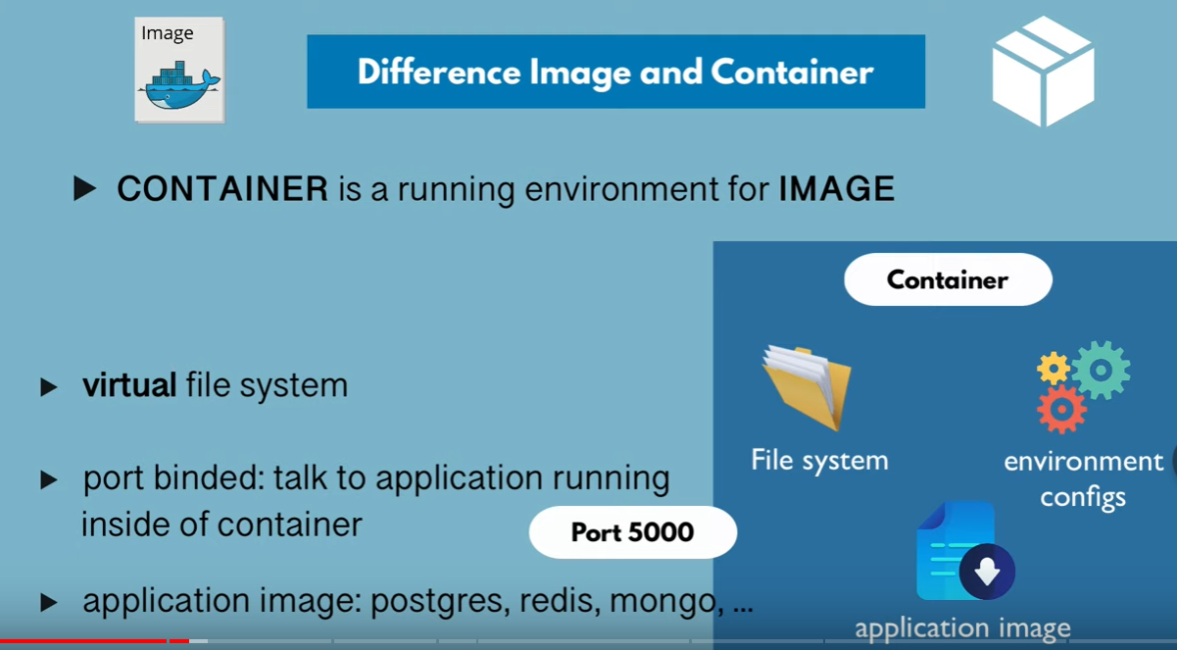

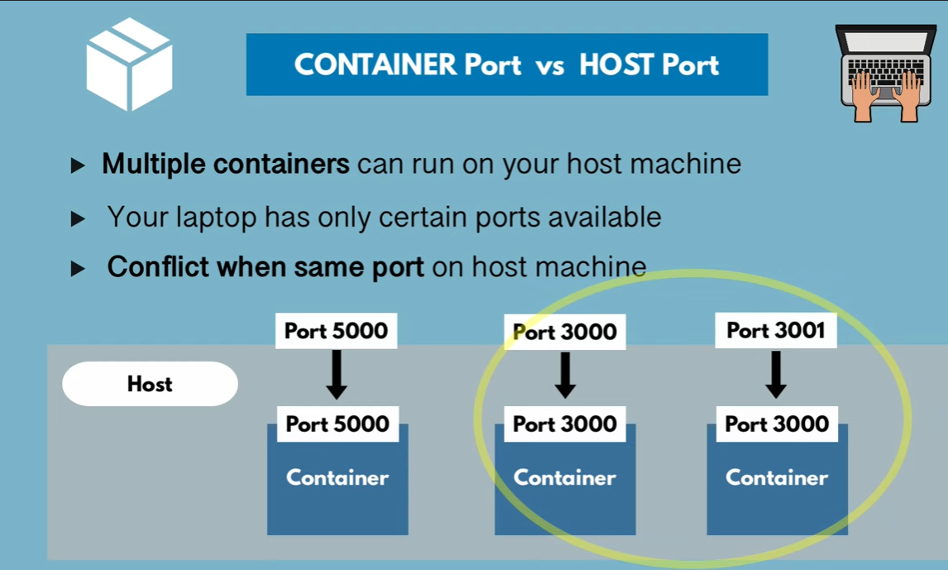

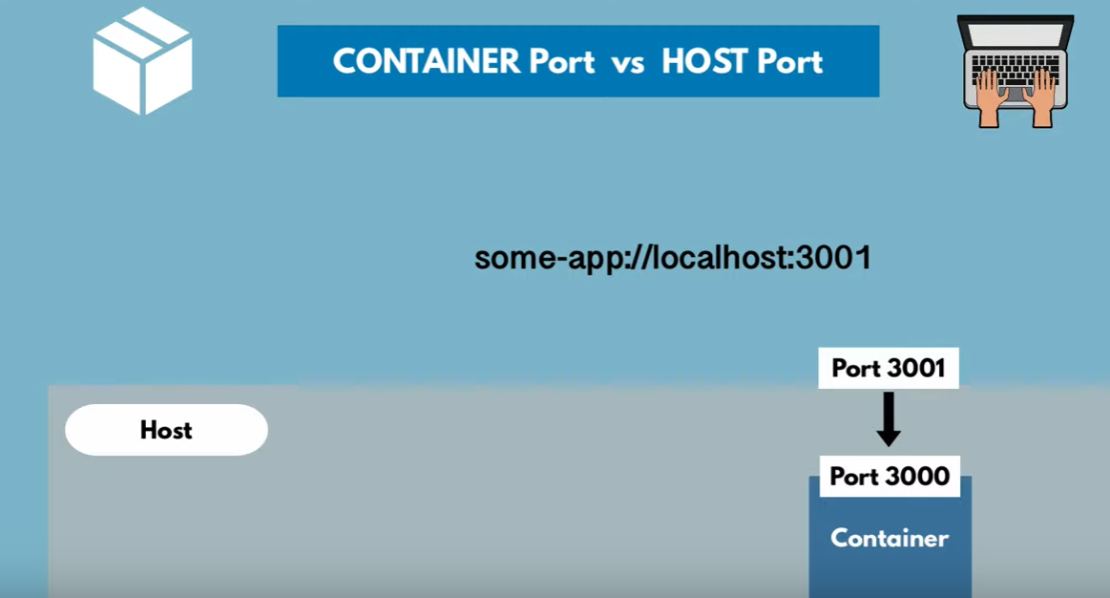

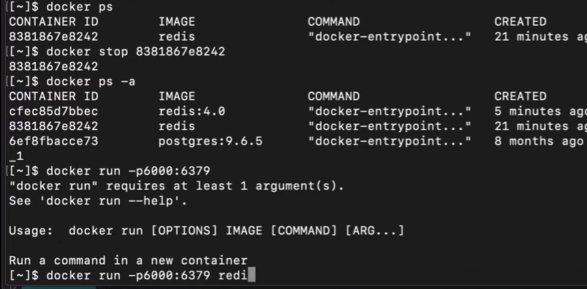Port binding from local to container host

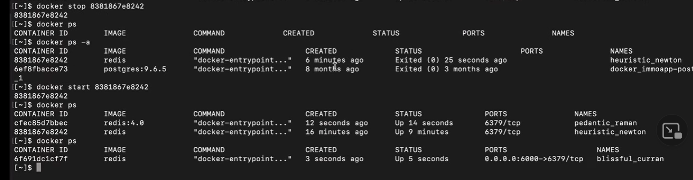

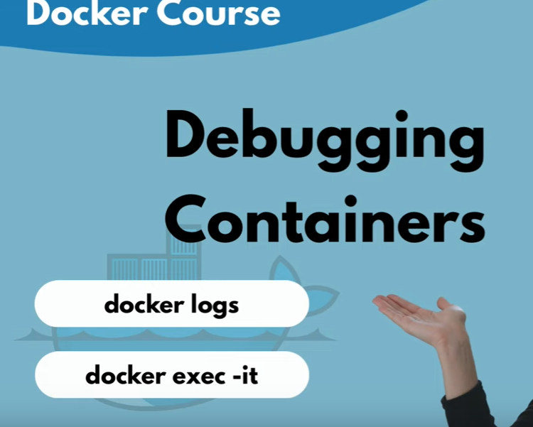

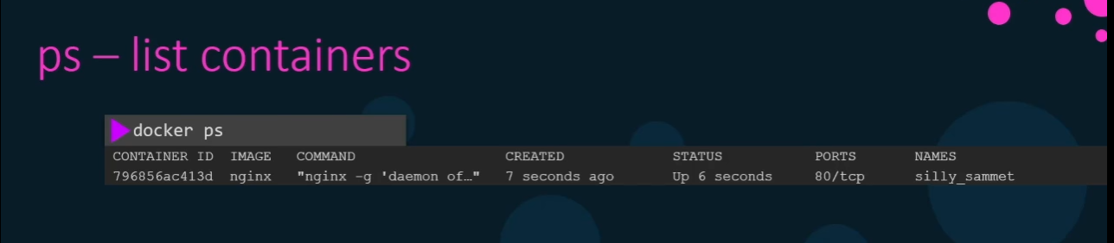

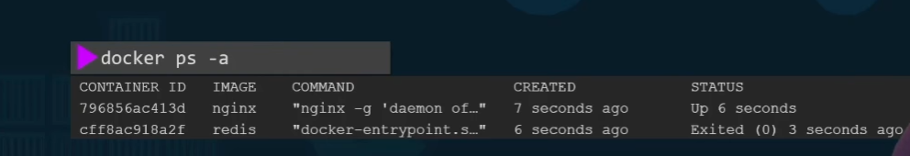

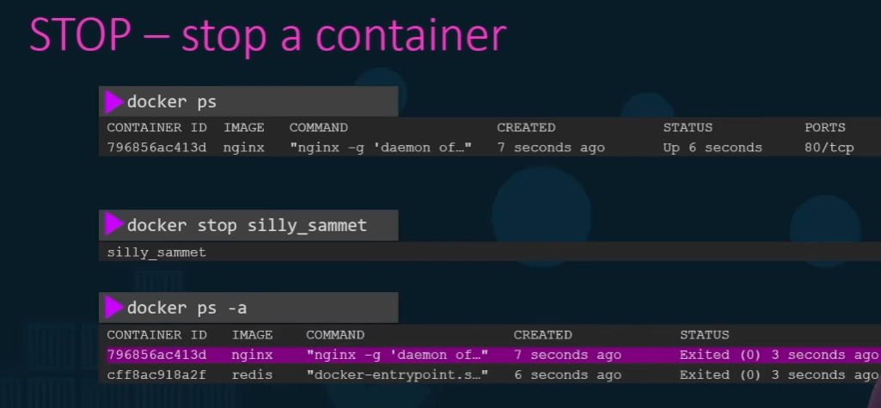

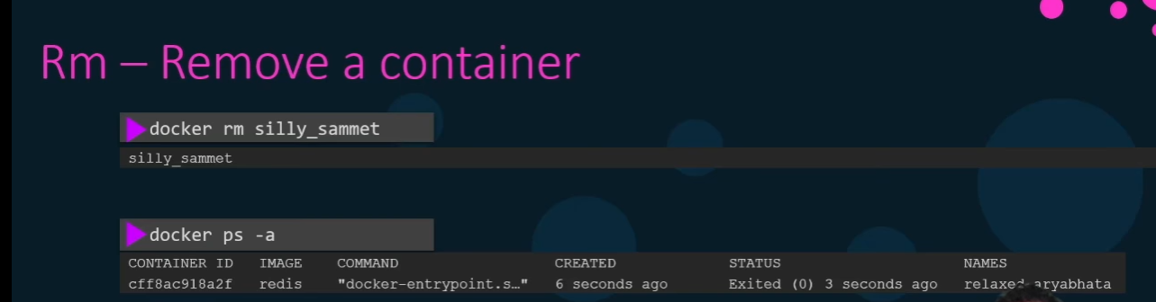

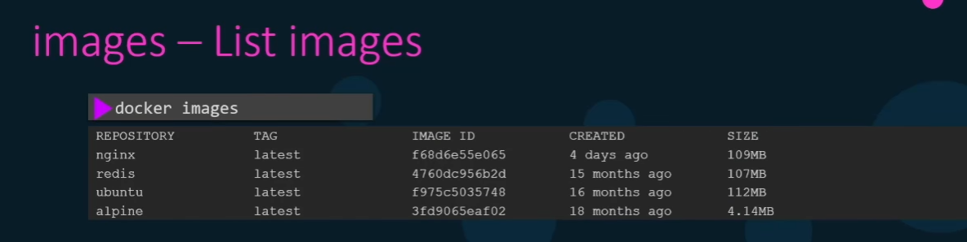

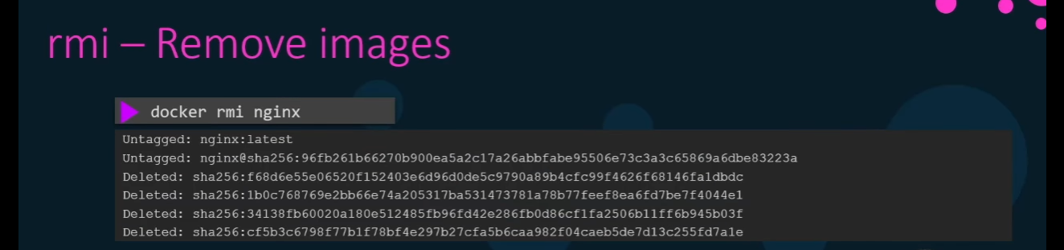

No container should be running using the above image then only it removes.

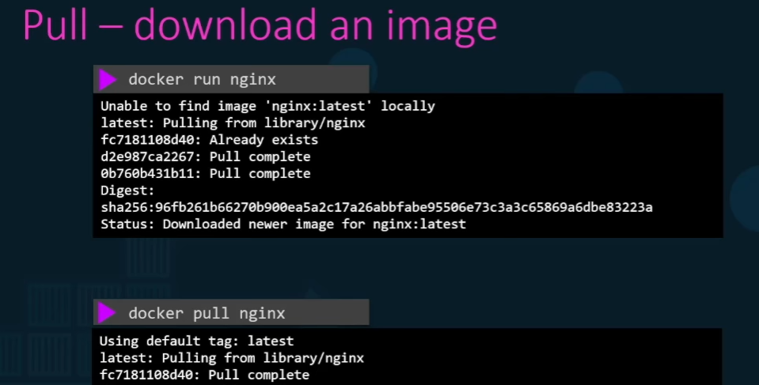

When the new container run the status should be in exited state by default.

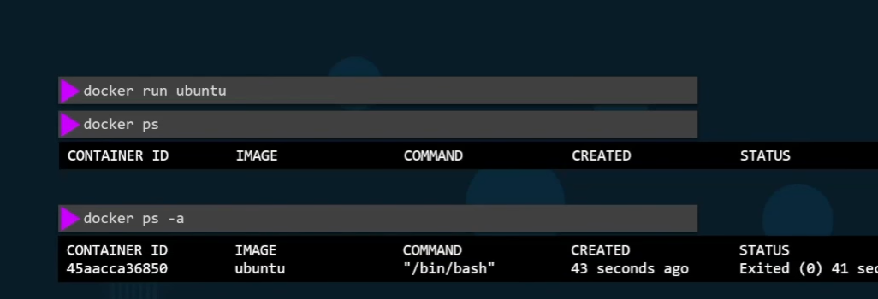

After running the container, it goes into sleep state after 5 sec it means stop the container.

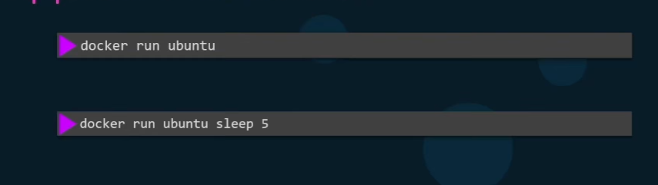

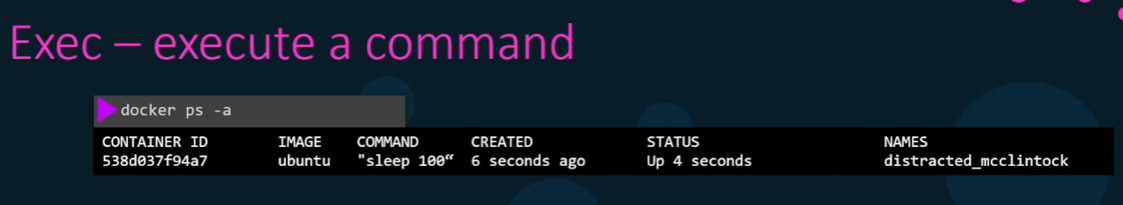

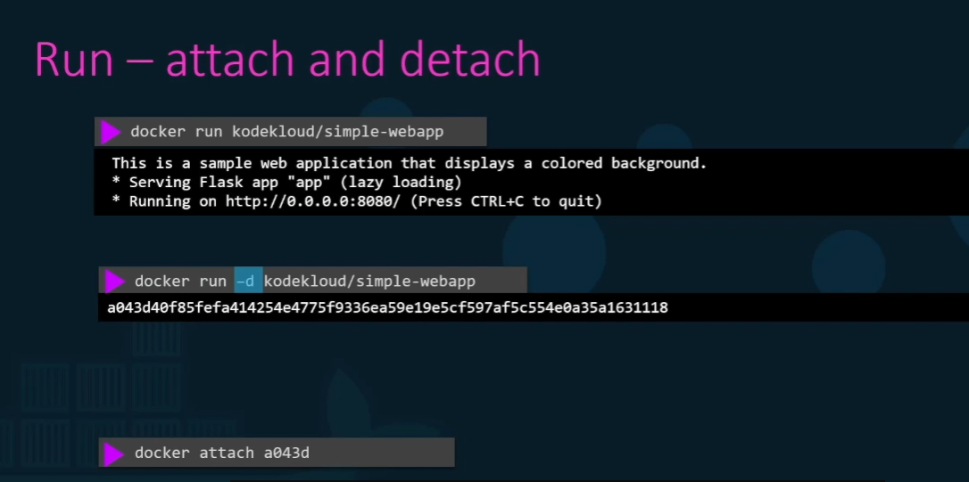

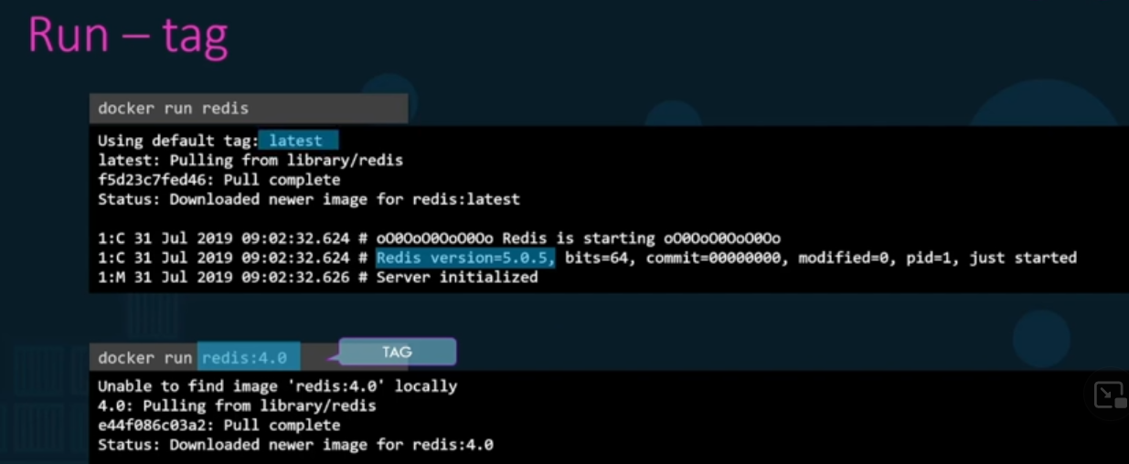

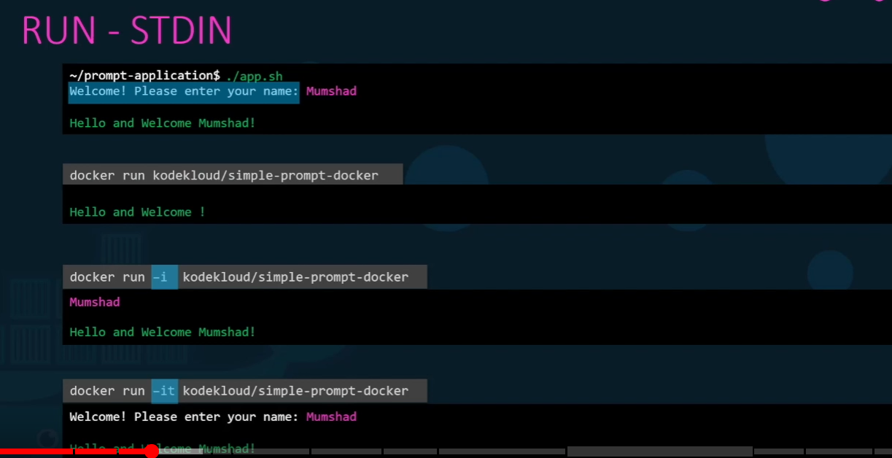

If we use interna ip to launch any url it doesn’t work,

We need to map from internal ip with external ip address.

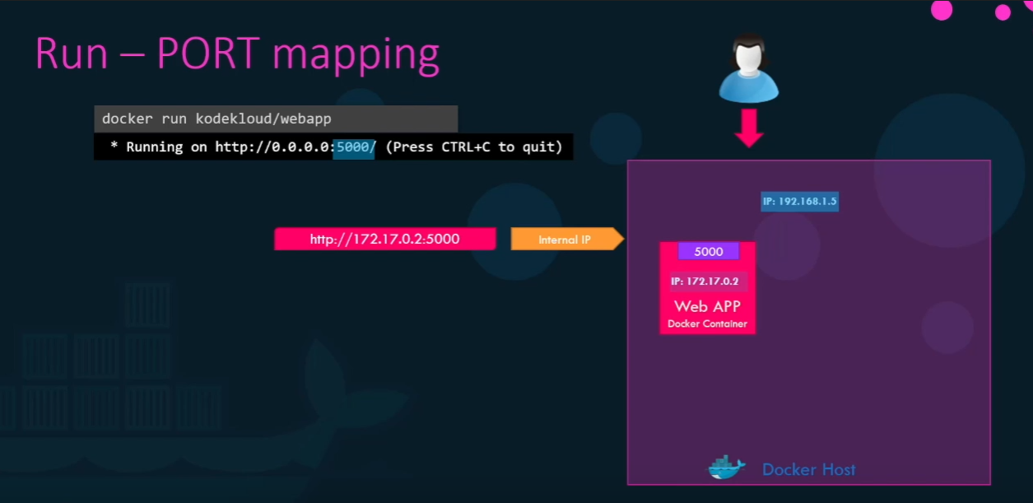

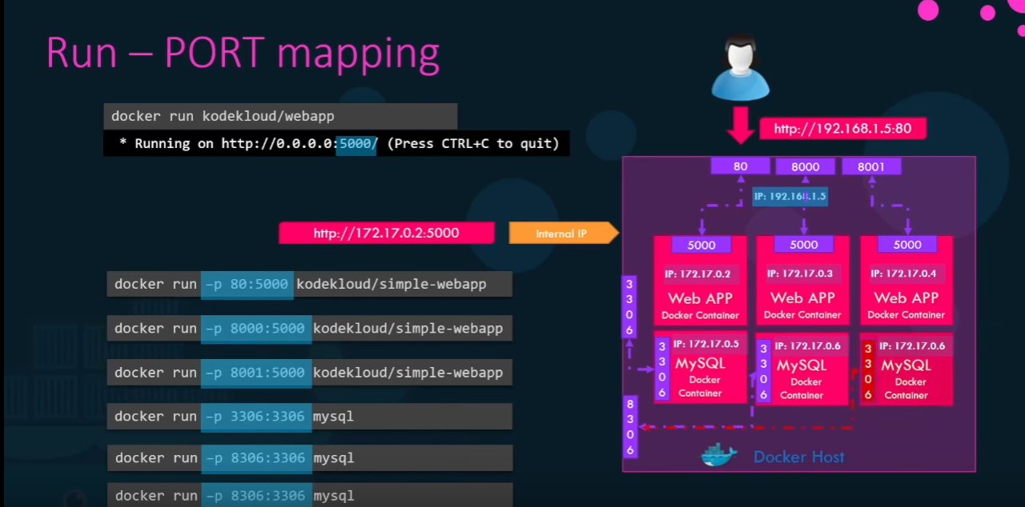

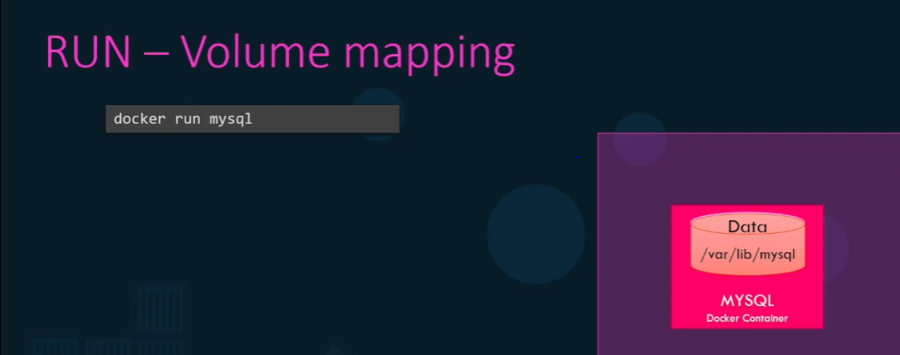

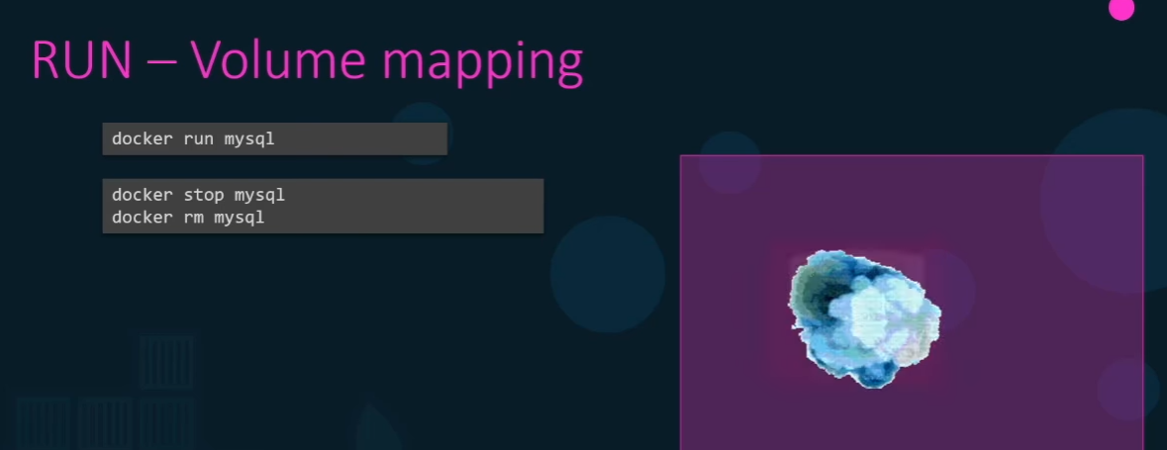

Below way we can mount data using external folder, even though we delete the image it stores in external volume.

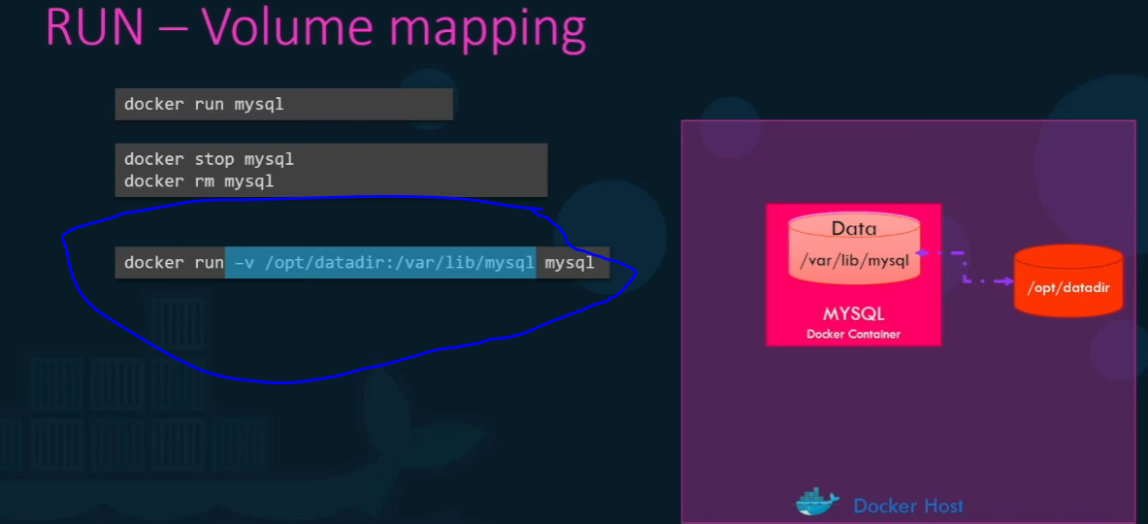

To know more in detail about container below command

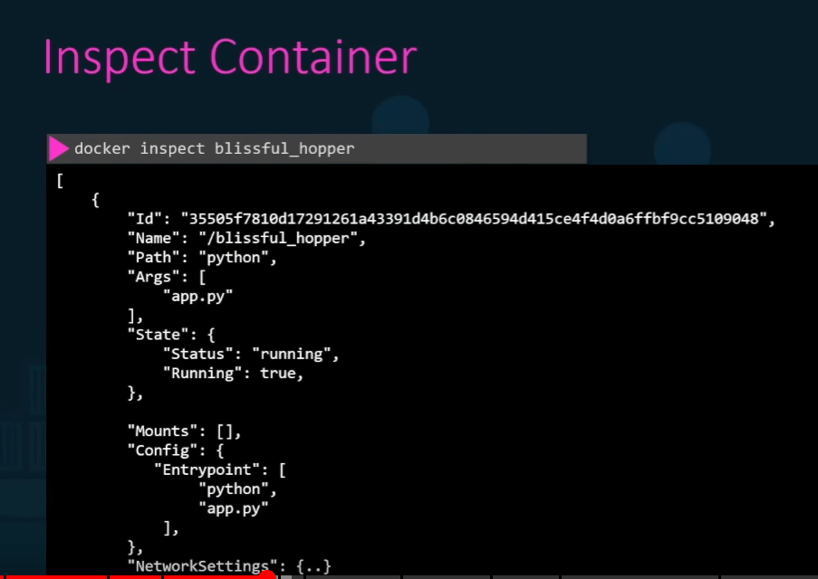

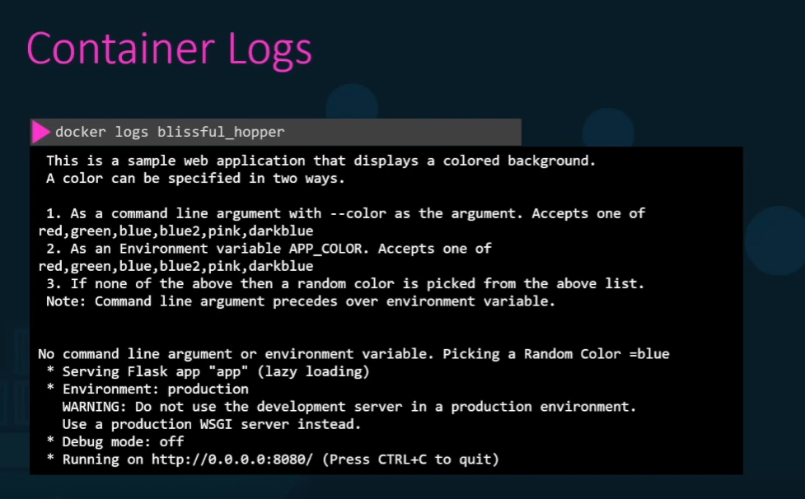



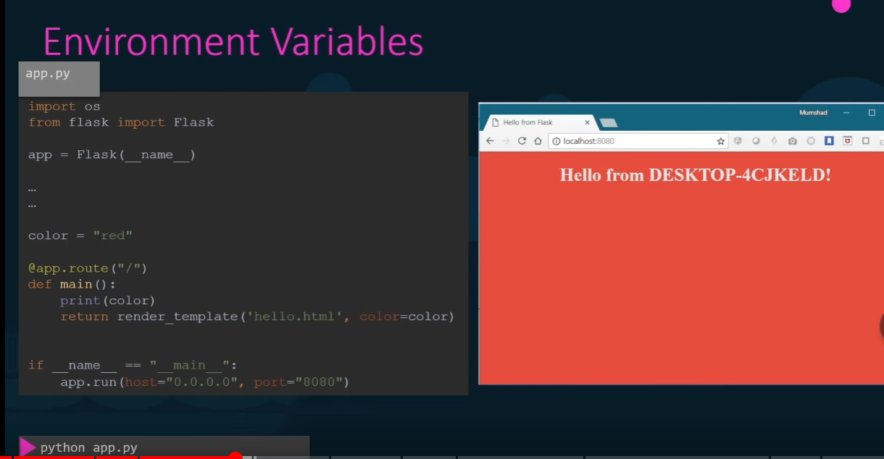

To change the env colour we need to change the code that is not a best practice, instead of this we can specify it in env variables.

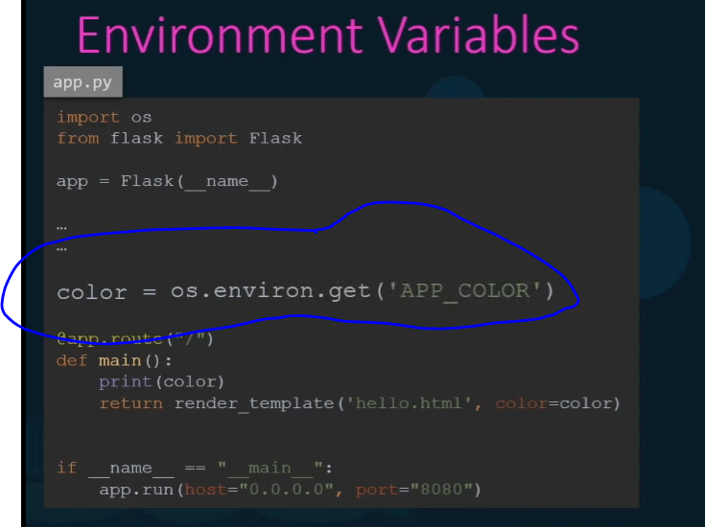

Now the application has new color

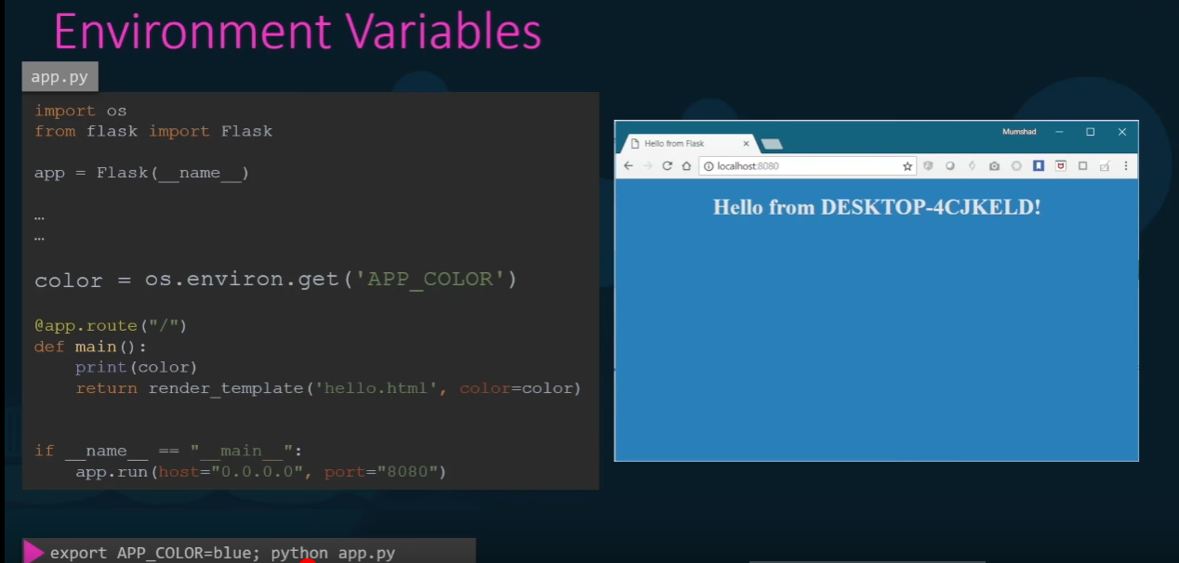

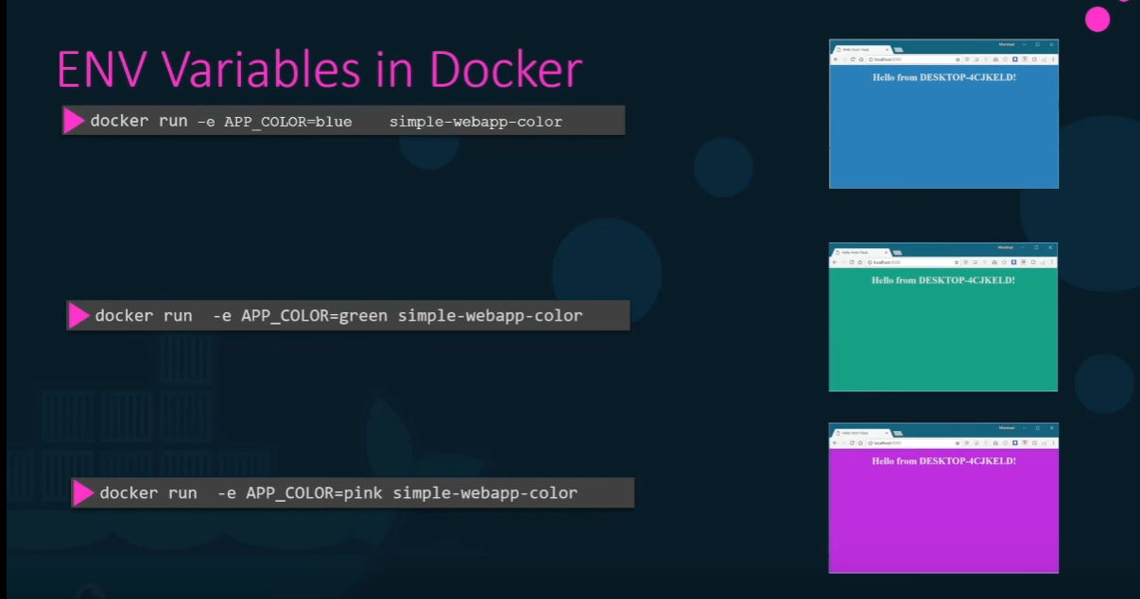

-e defines env variables

To find env var set on the container

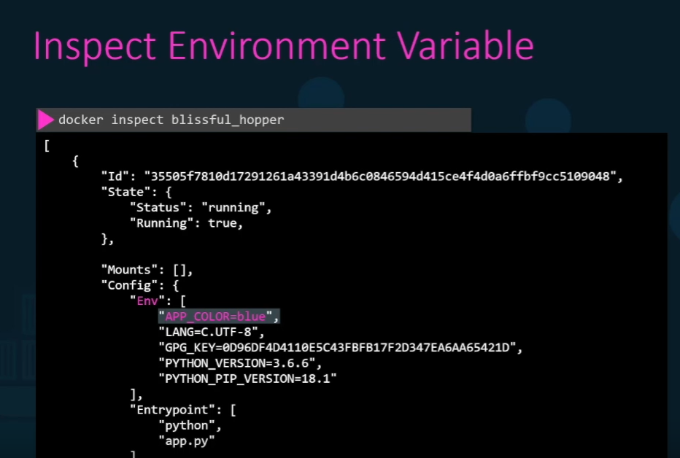



Usually we follow below steps to launch the browser.

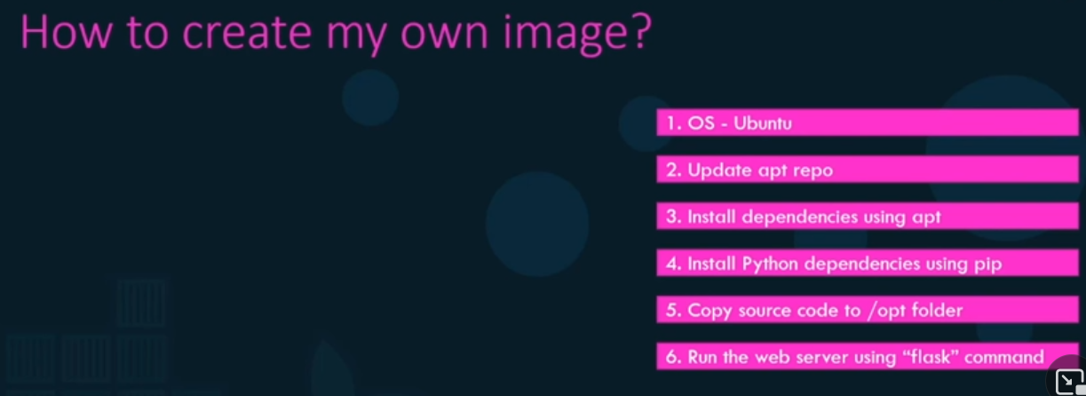

Using Docker file we use below commands to execute.

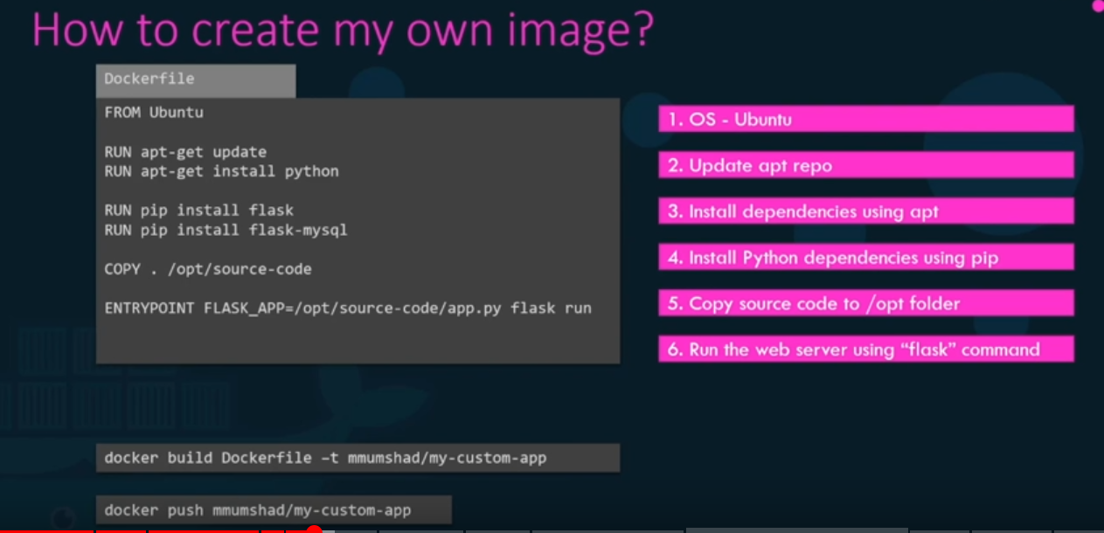

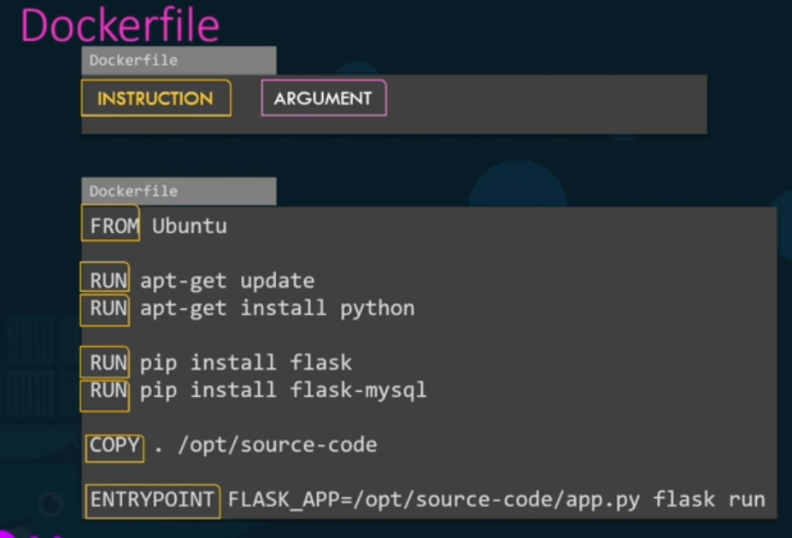

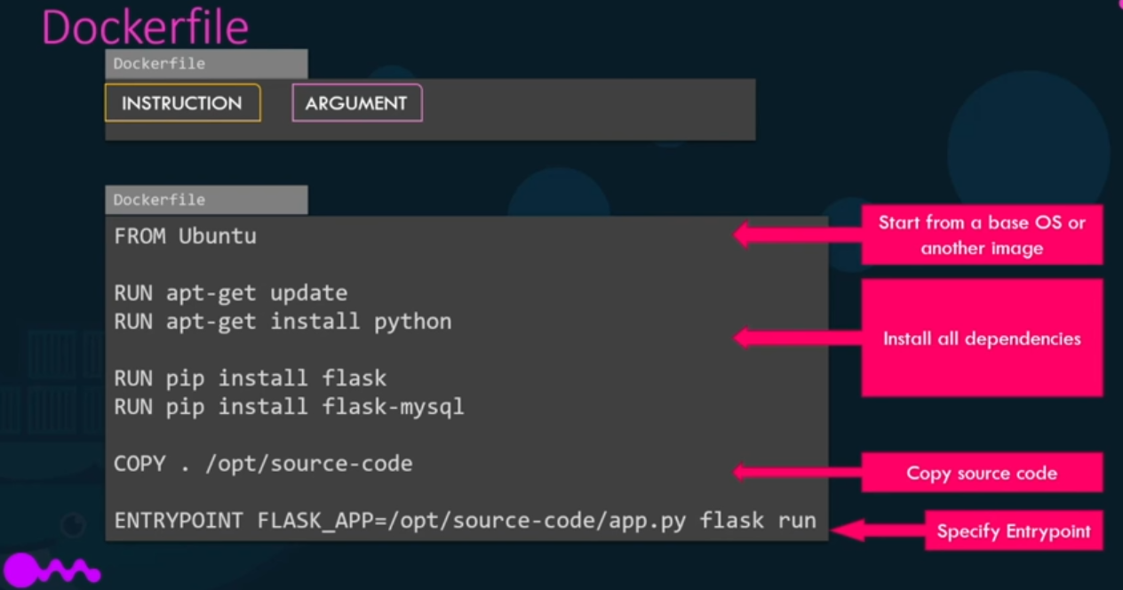

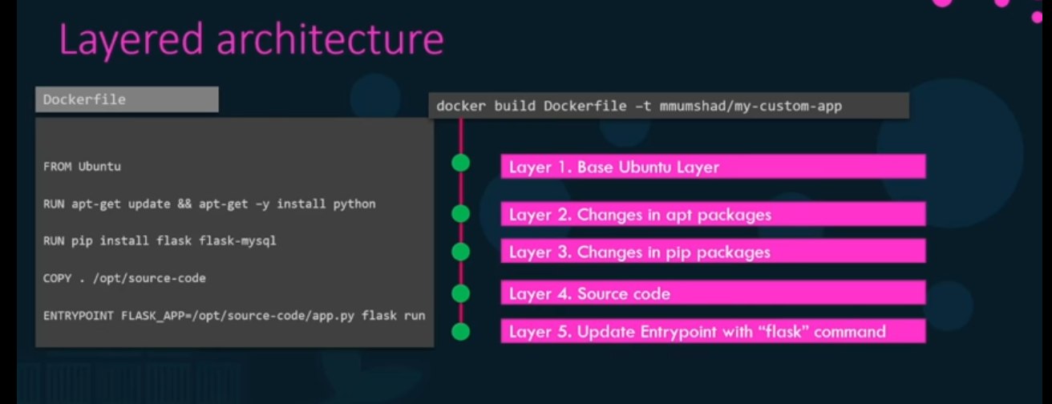

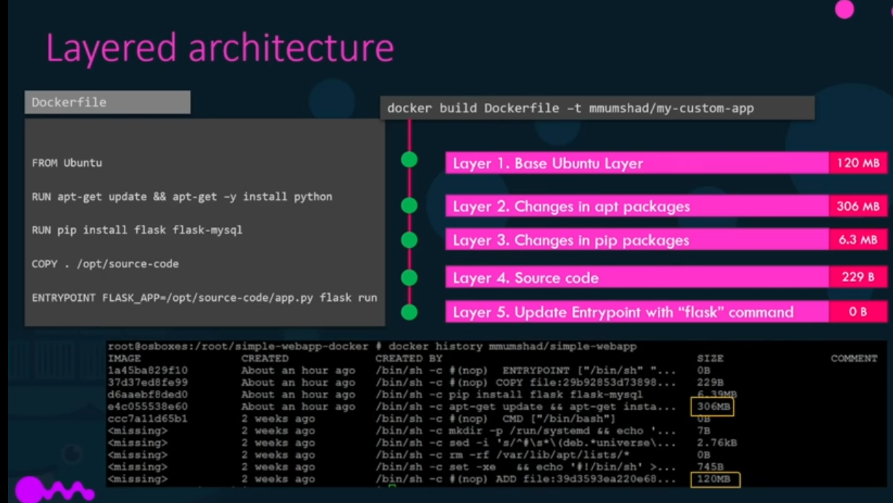

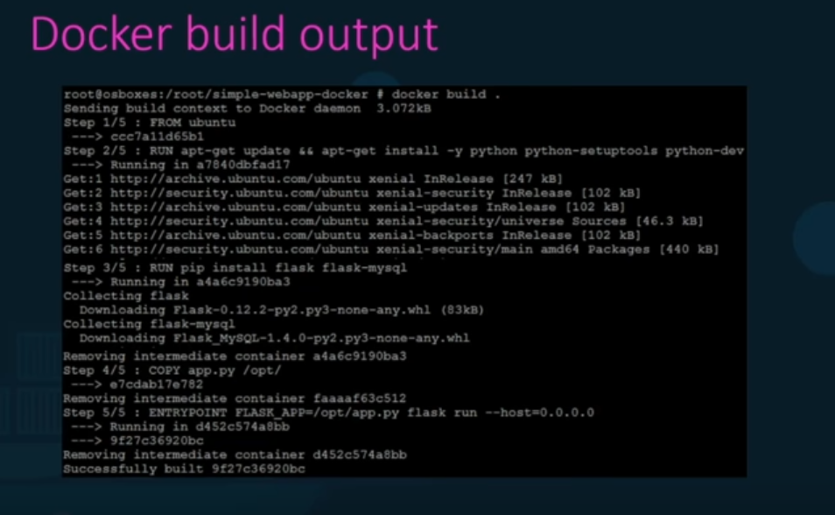

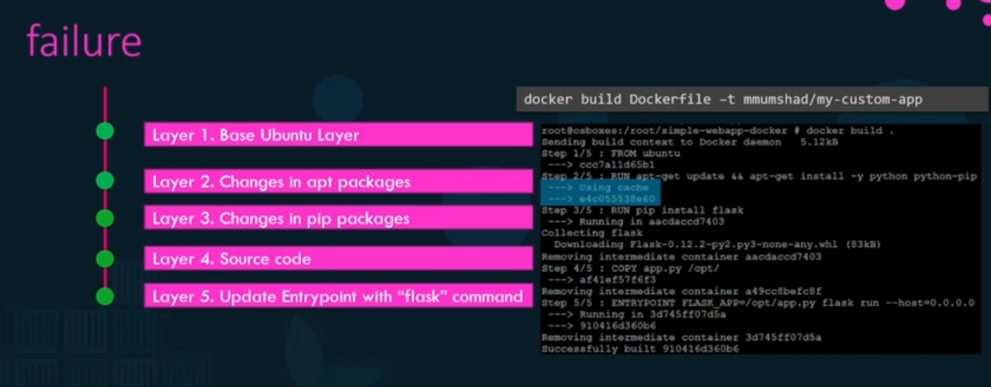

No need to install everything we can run image and use it in container and then clean it.

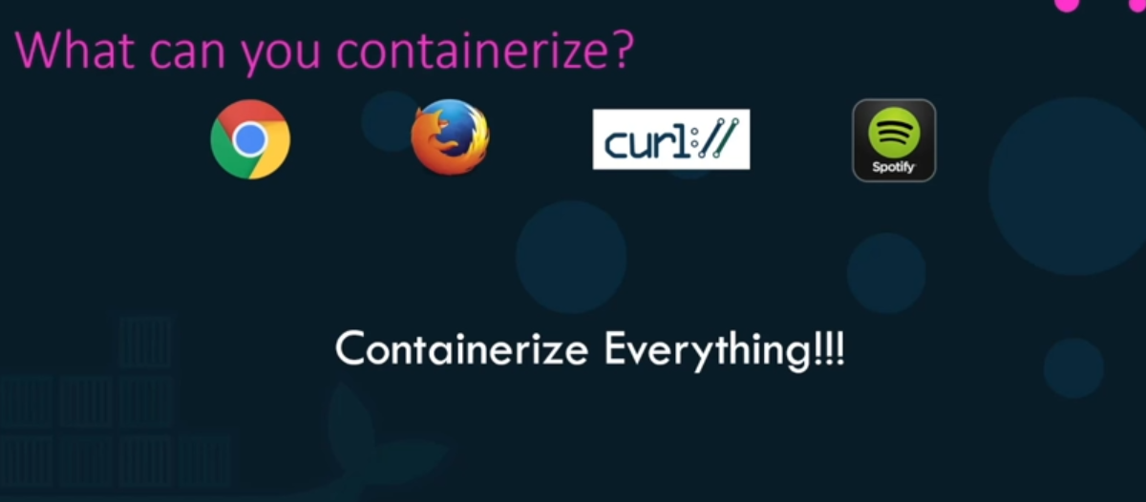

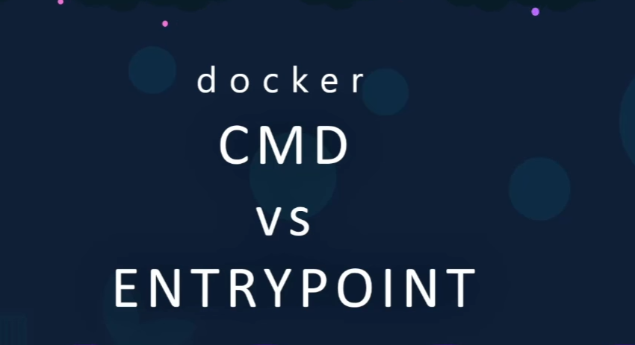

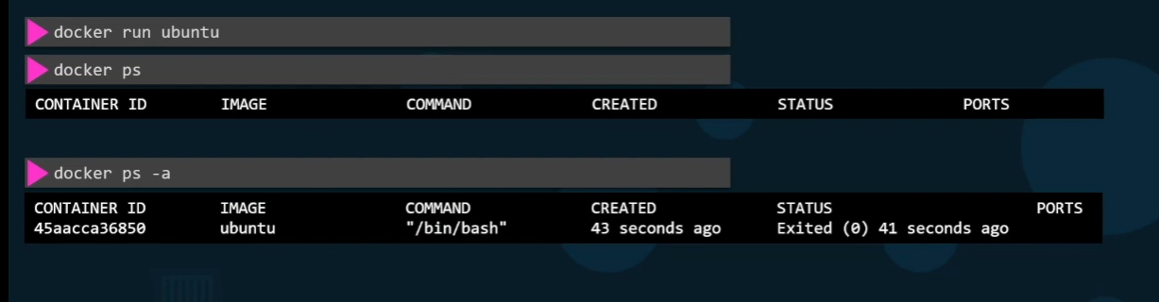

When we run any image there will be no list of containers running, if we see status it will be in exited state buy why.

Containers r not met lo host Operating system.

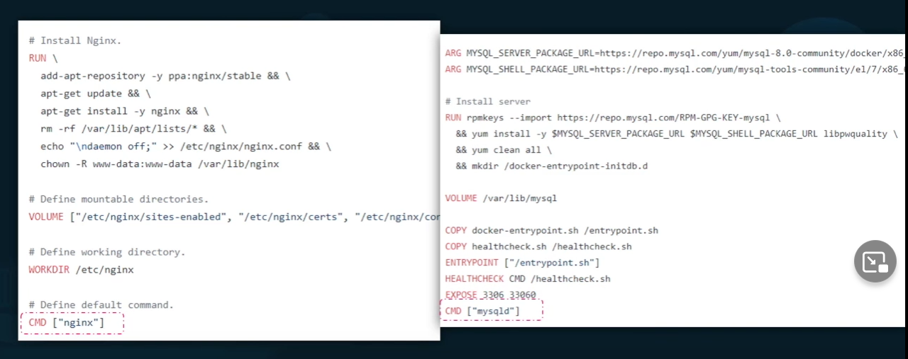

Above cmd to run Nginx and mysqld is cmd.

Suppose when we run image container doesn’t know which terminal to pickup so it goes to stop state.

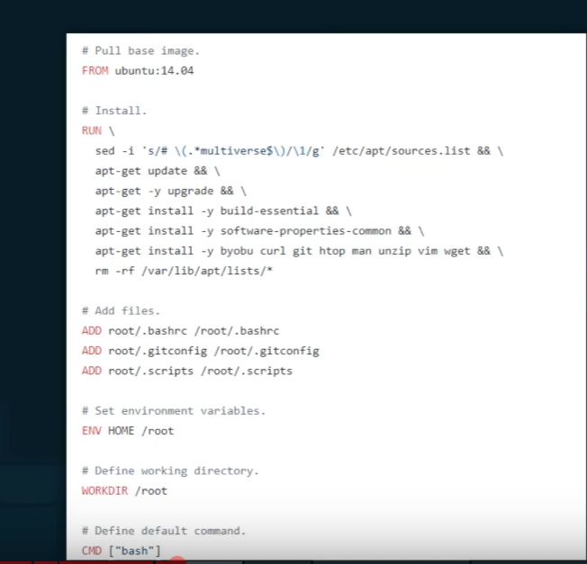

Bash is a shell if it knows it executes else it fails to execute.

By default, docker doesn’t attach a terminal to container when it run

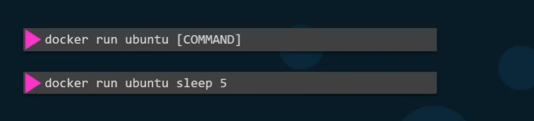

Here container waits for 5 sec and then executes.

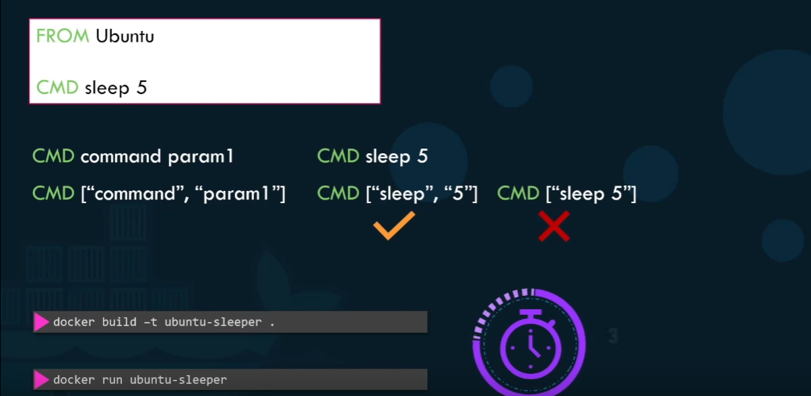

We can declare in Json format within docker file.

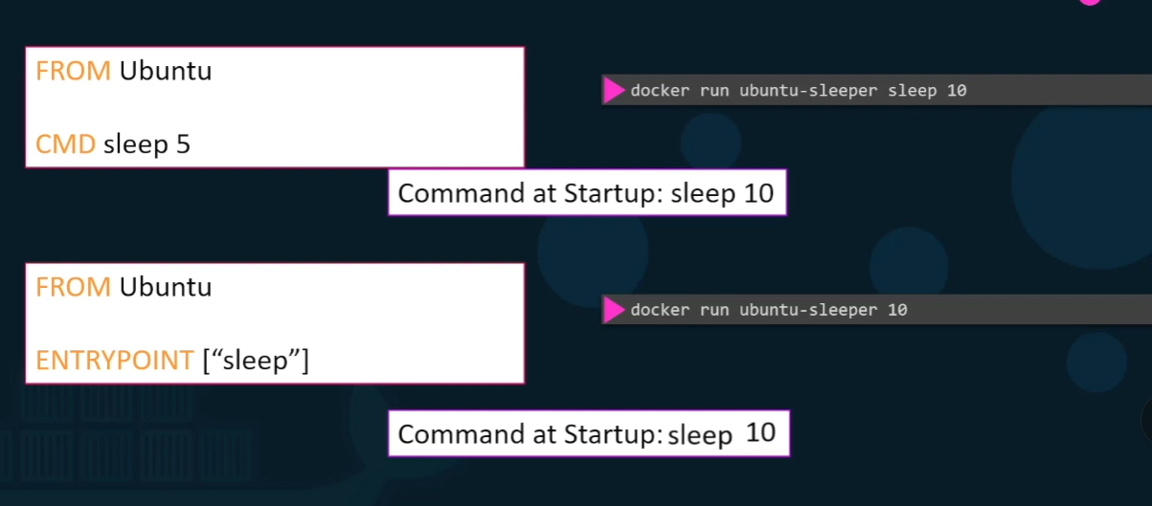

For above img,

In 1st declaration CMD, CMD parameter get replace entirely where as

In 2nd declaration Entry point, CMD parameter will get appended.

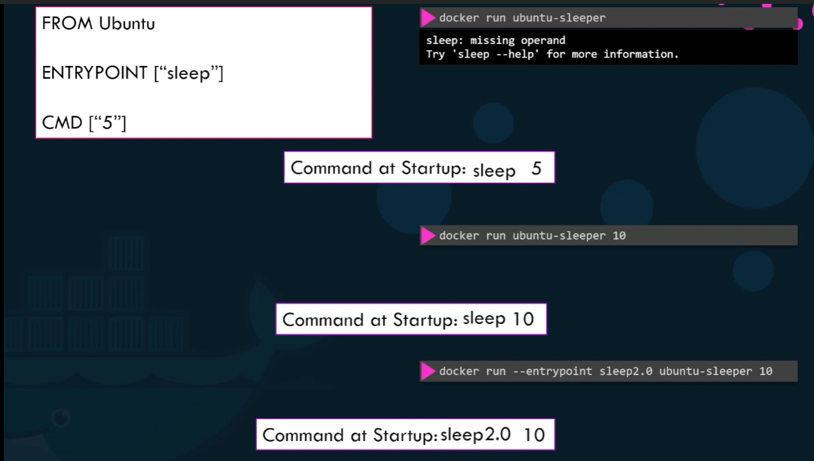

In above if we won’t specify any time it gives error

We can declare without giving any time and declaring time in CMD, as both in Json format

To override time in runtime 3rd cmd is should be declared accordingly.



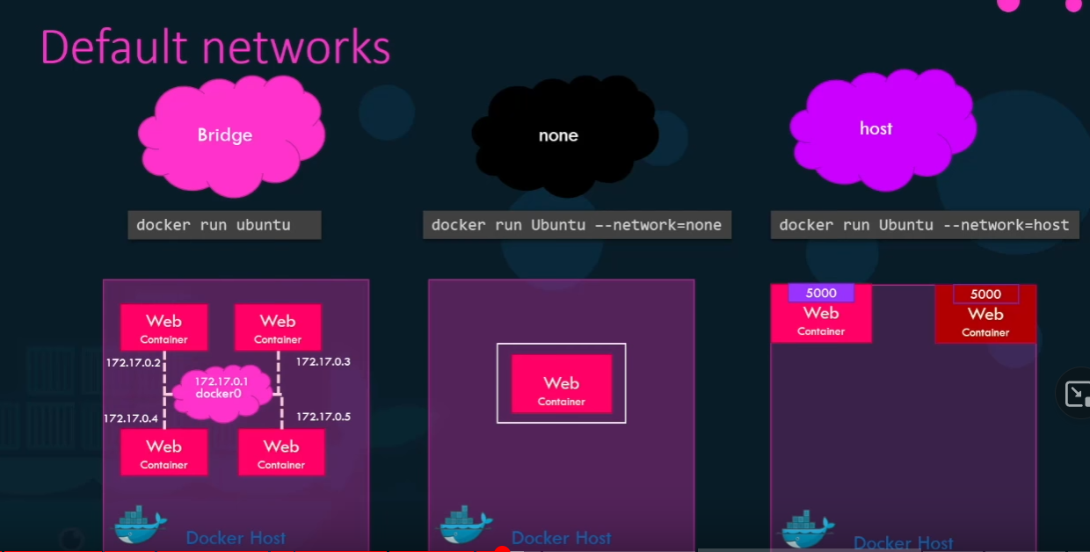

If we have 2 different internal n/w we can create our own default internal network using below command.

To check the list of network and its ip addresses using below 2nd cmd.

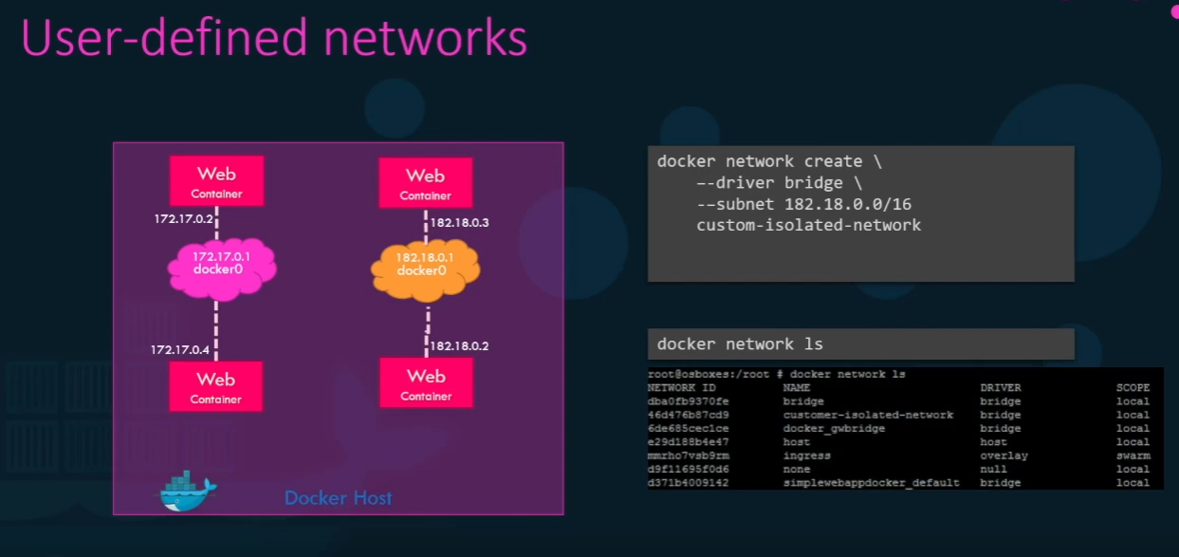

To check network setting

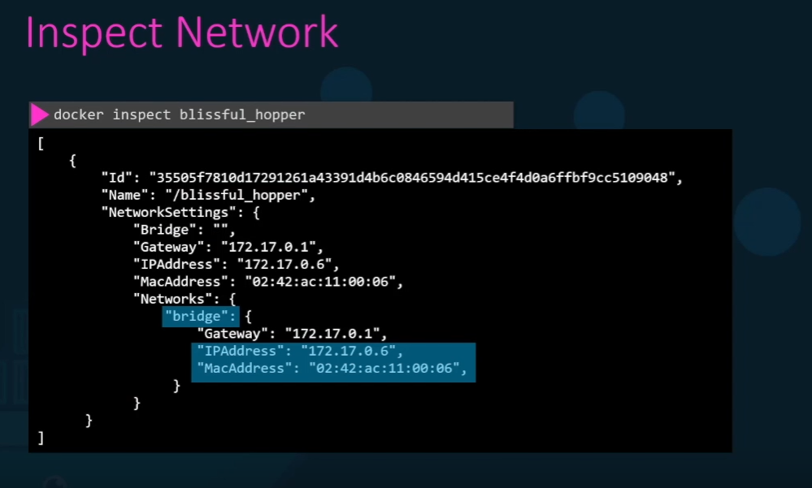

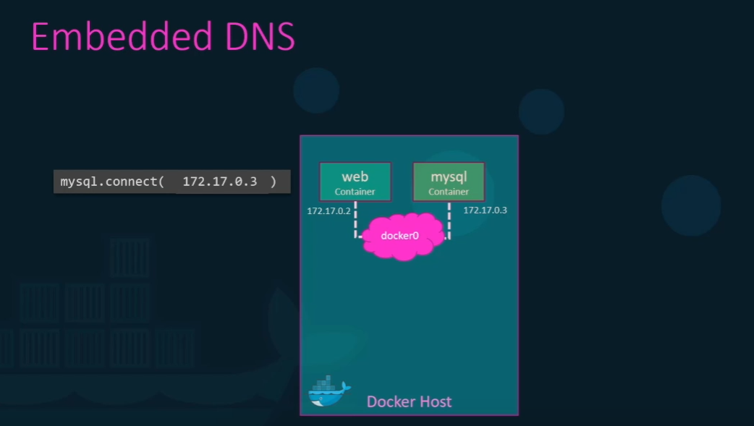

To connect both the servers with docker , using virtual ethernet pair we can connect it as below.

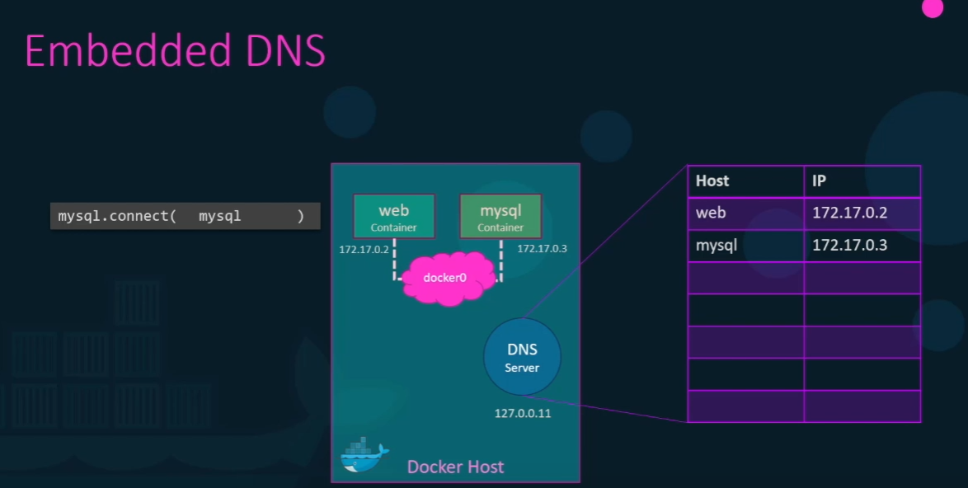



We can see the storage of docker and how it manages the file systems.

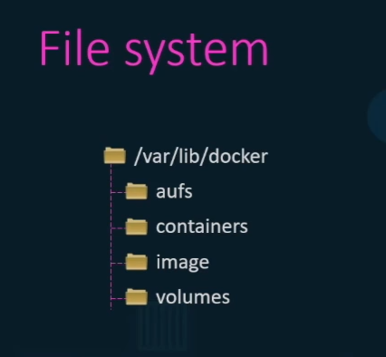

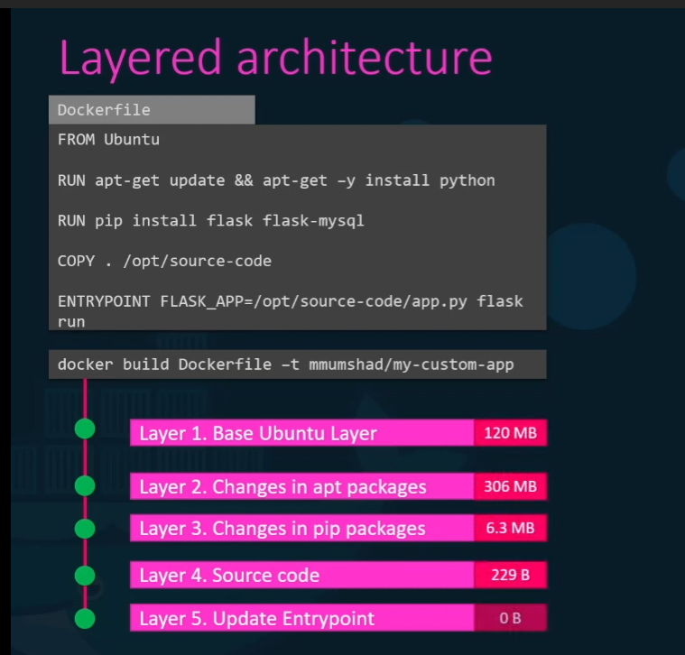

If we change the app to execute the file it will takes all the layered executed steps from cache file and performs as below

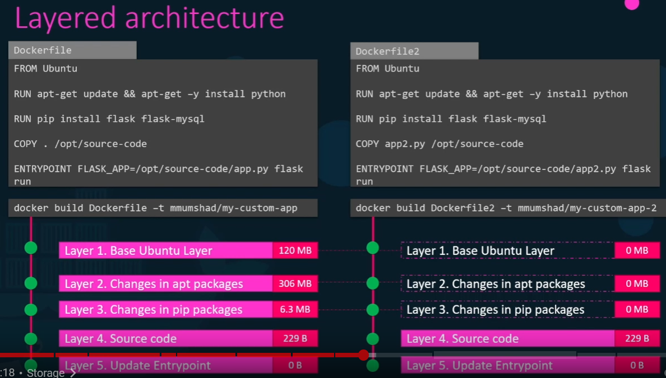

Same Image with execute to create all the containers using this

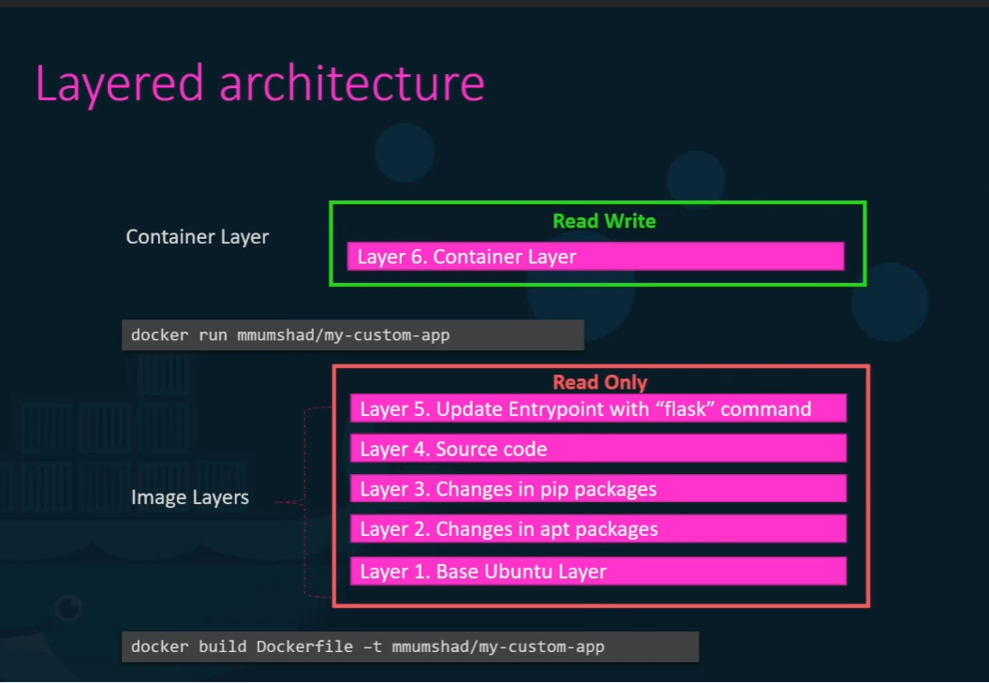

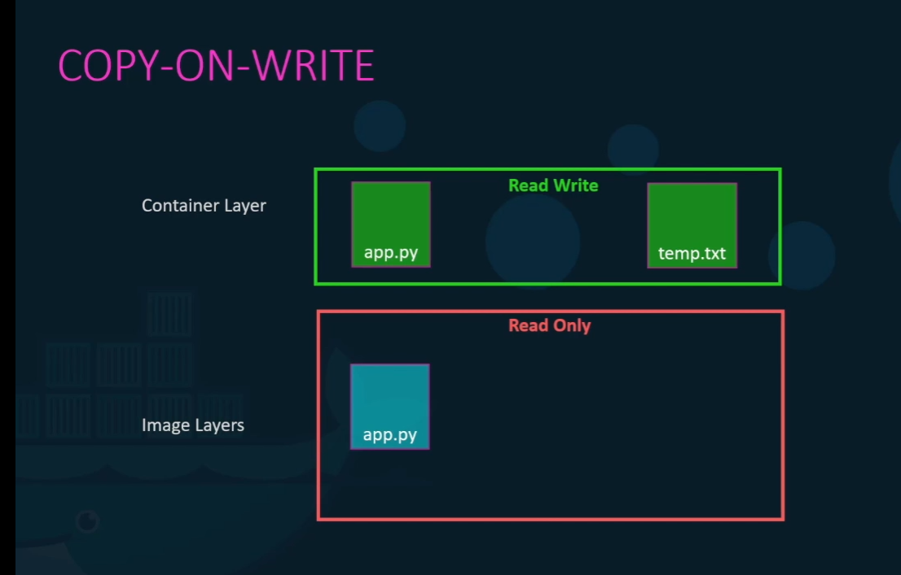

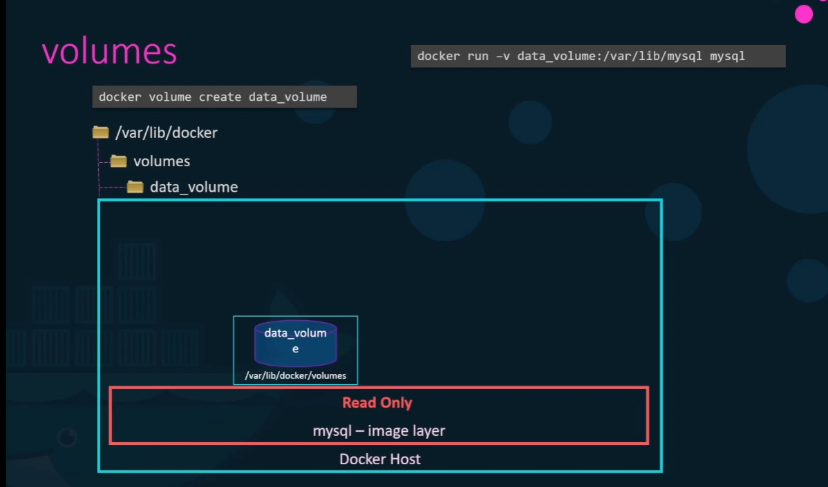

Mount Volume as below:

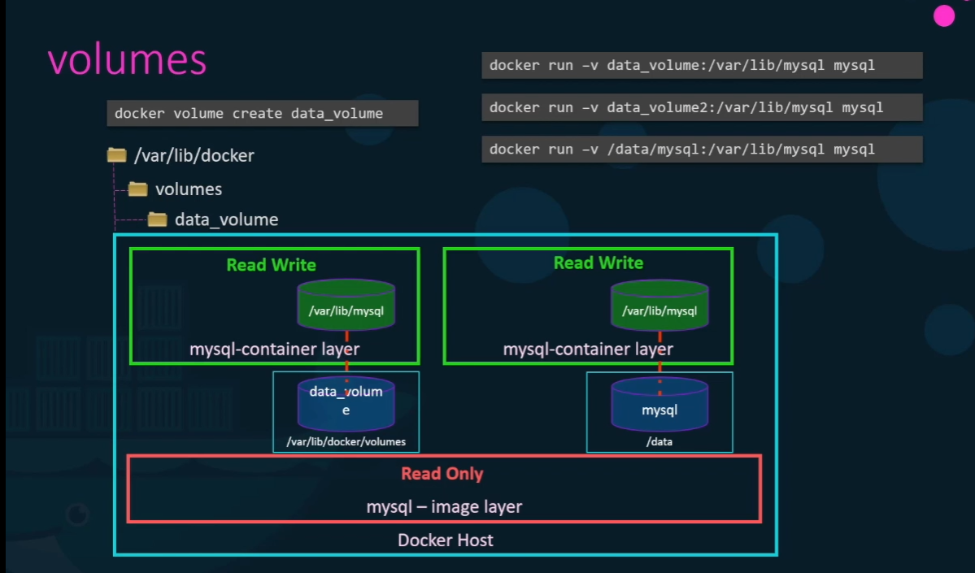

2 types of mount are there

a. Volume Mount – Volume mount the mounts the volume from the volumes directory

As in 1st data volume folder : 1 nd 2nd cmds relates to docker mount.

b. Bind mount - mounts the container from any location

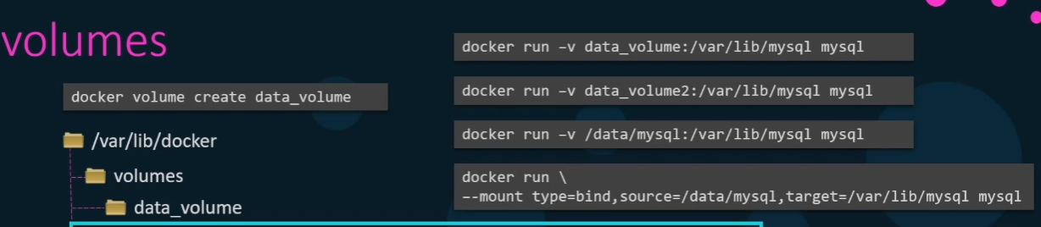

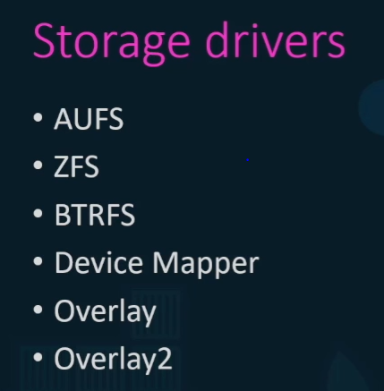



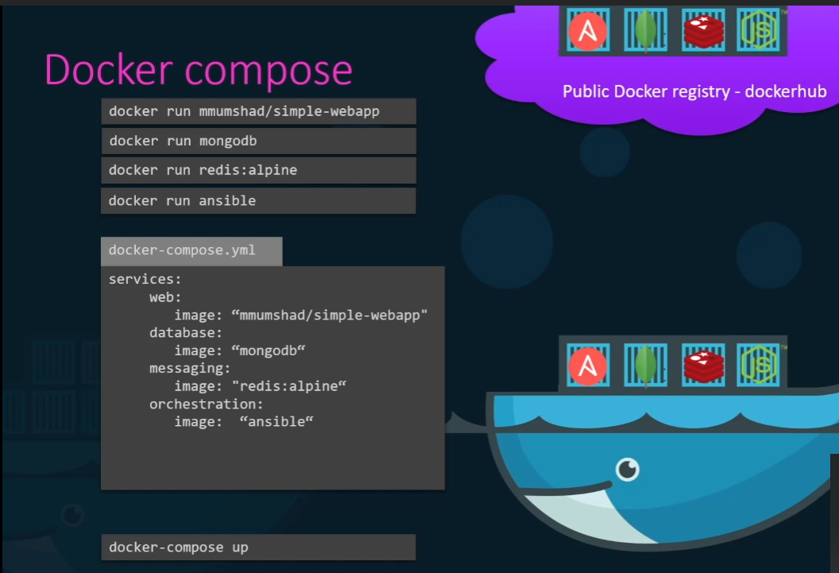

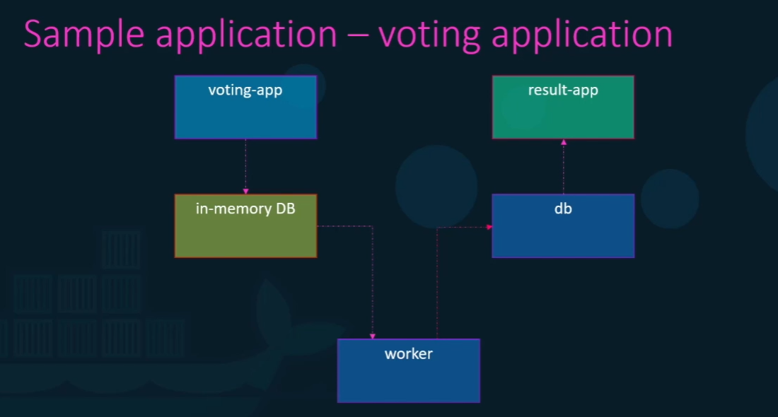

Lets assume all the images of docker are build and ready in data layer

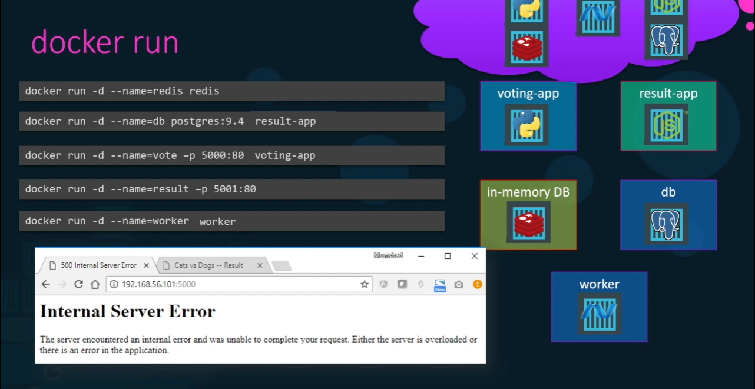

Error is becoz we haven’t told the particular container to run in the ip address, it may run multiple servers so it shows internal error.

To assign this we require docker-links

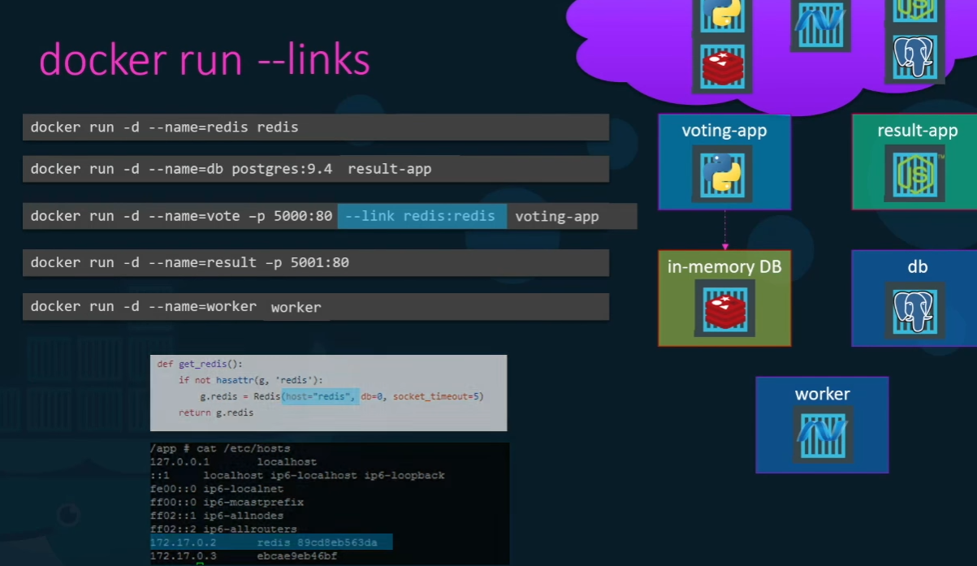

Voting-app links db to redis, the link assigned within cmd as above.

Docker worker require both db and redis so the declaration as below

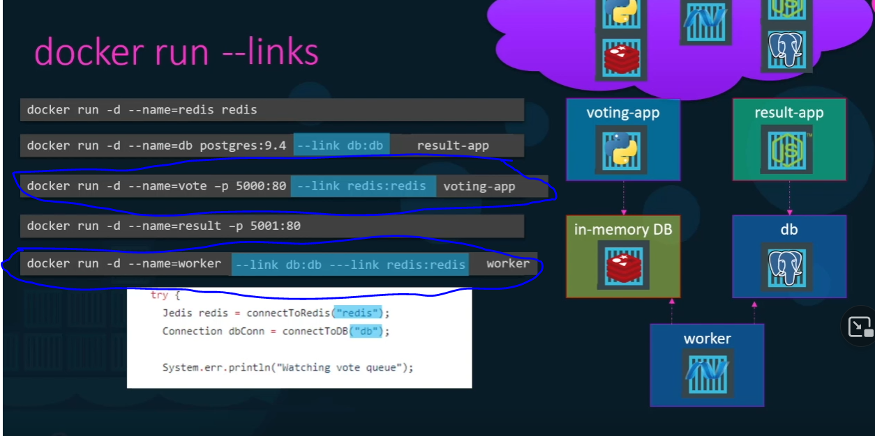

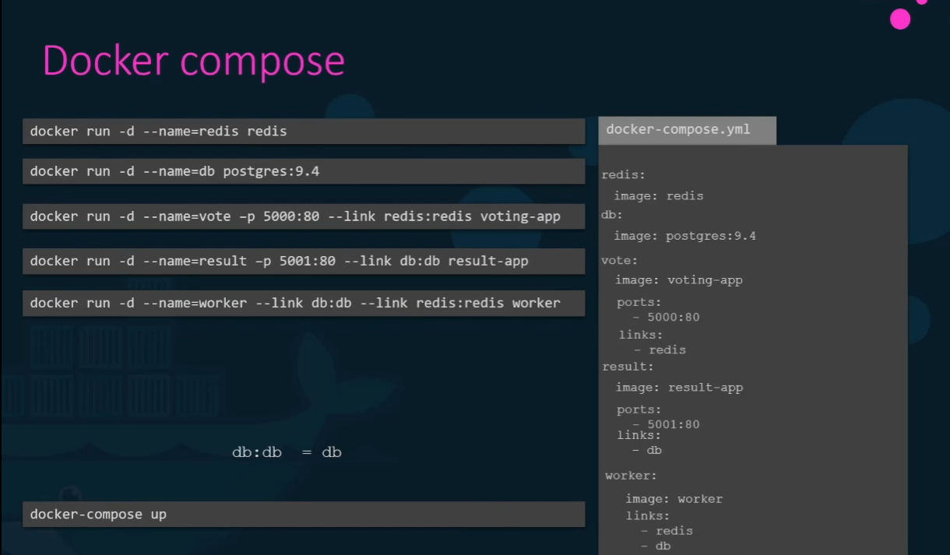

As compare to above commands declared in docker run we can compose yml file as above

When we write yml file in docker compose we may think all the application r already build, but only redis and postgres r already build, remaining r written and not necessary to build and not available in docker registry.

We can build the compos file as below

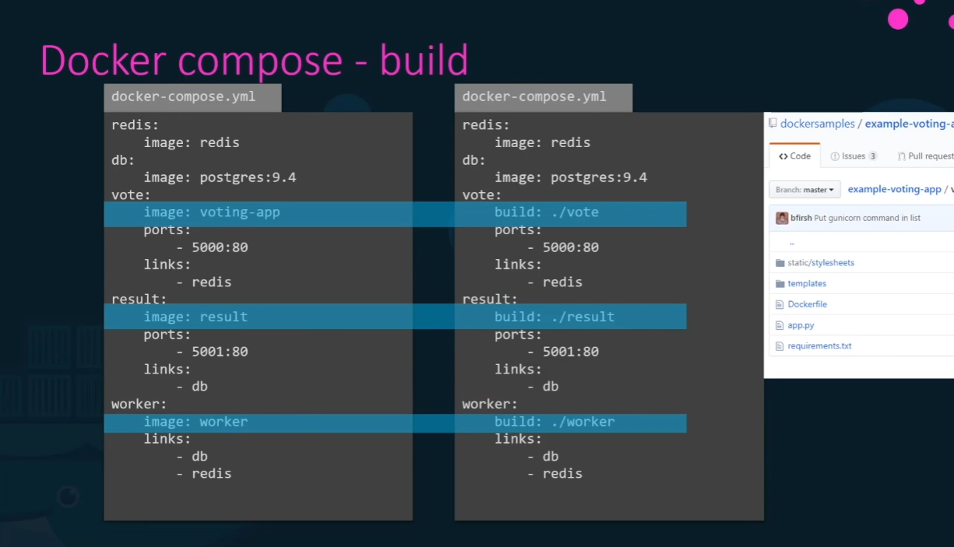

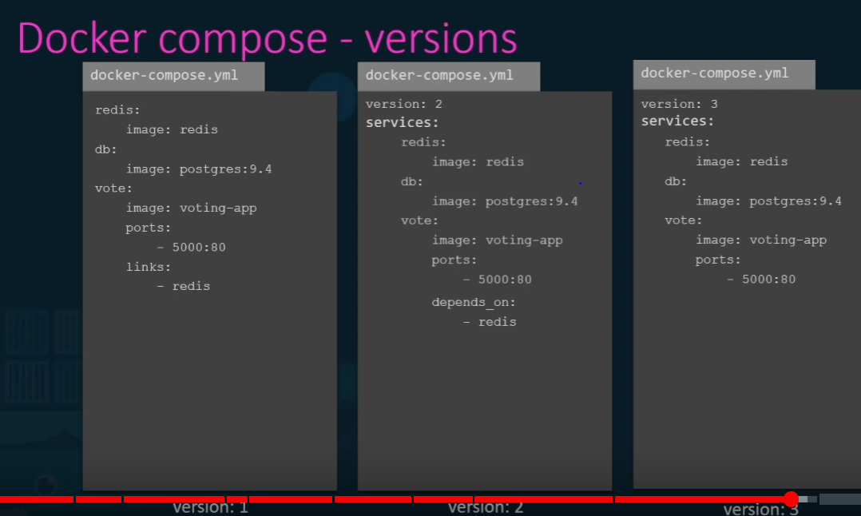

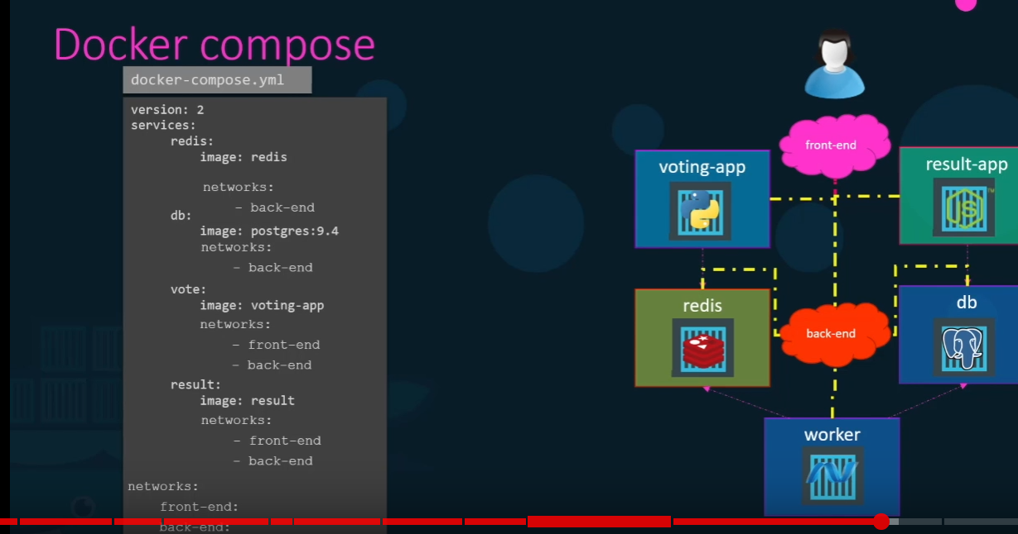



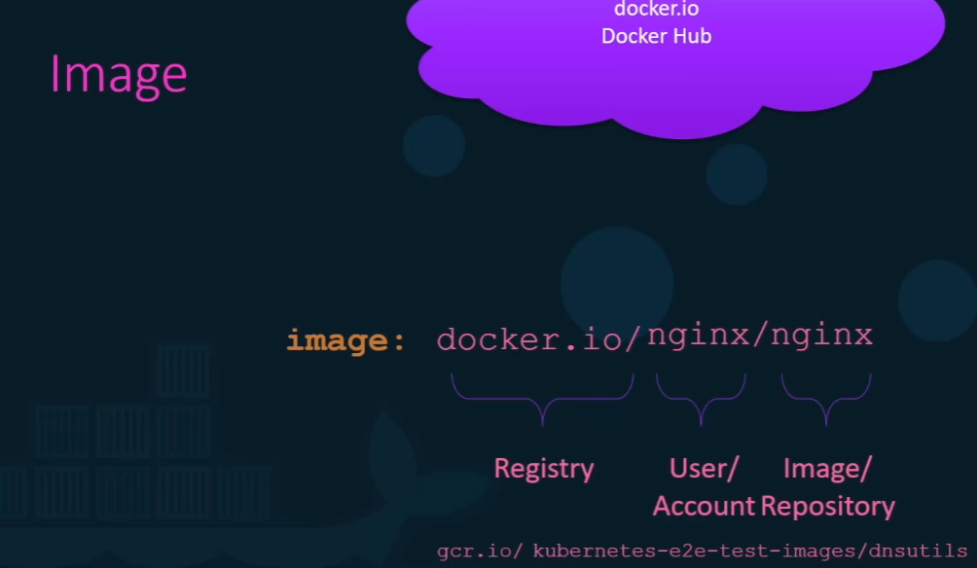

Dockerhub is an registry.

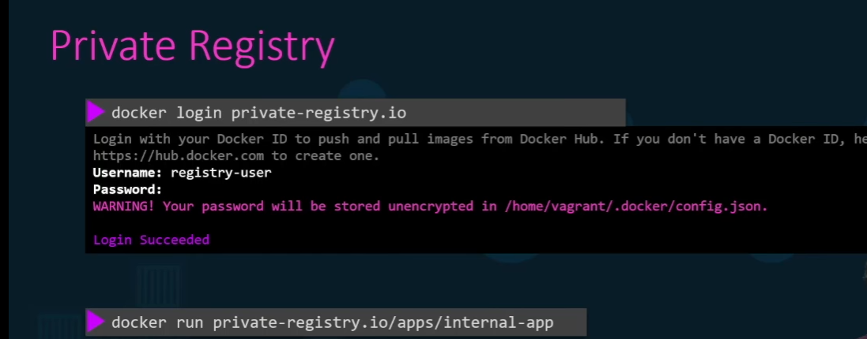

Every time to push or pull the images we need to login to registry

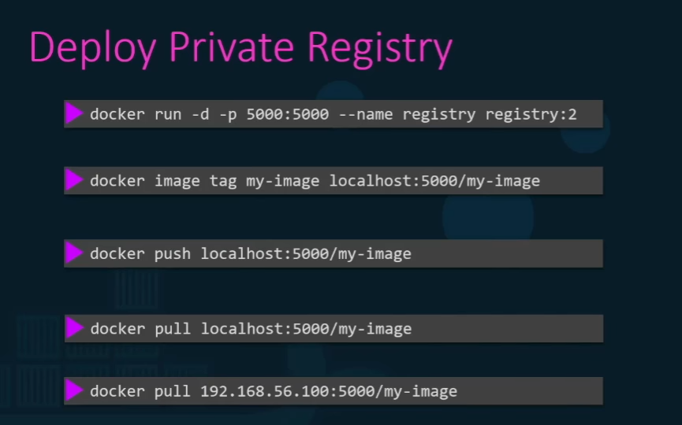

Suppose we r using any localhost like 1st cmd need to push the cmds as above to push or pull the image using localhost.



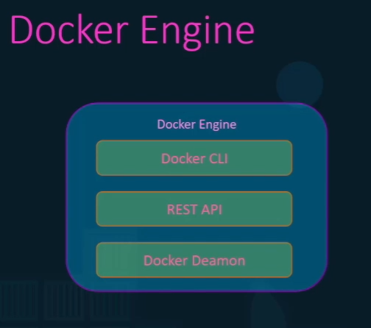

To install docker engine on linux server we use 3 different host on it.

Docker Deamon: It’s a background process that manages docker objects such as images, containers, volumes and network servers.

Rest API : It’s a server used to communicate with docker deamon and instructions, we can create our own tool sing this.

CLI : Command line interface is used to perform actions such as staring container stopping container, images, It uses rest api to communicate with docker demon,

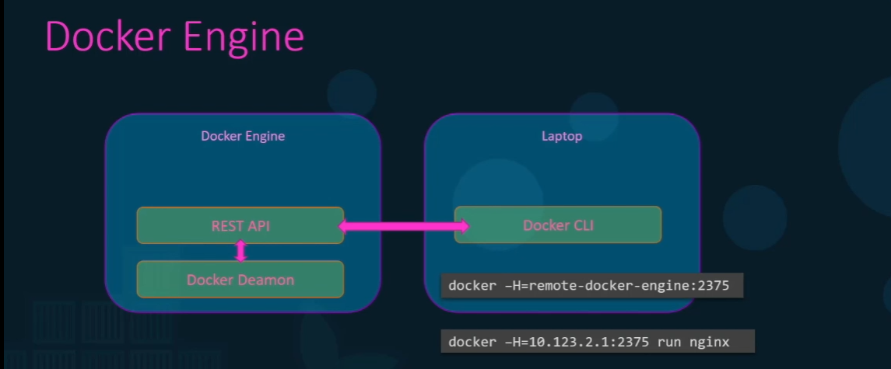

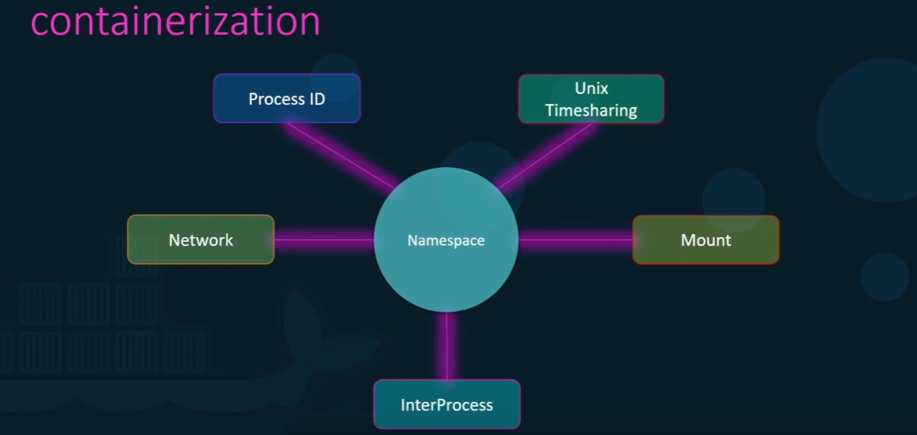

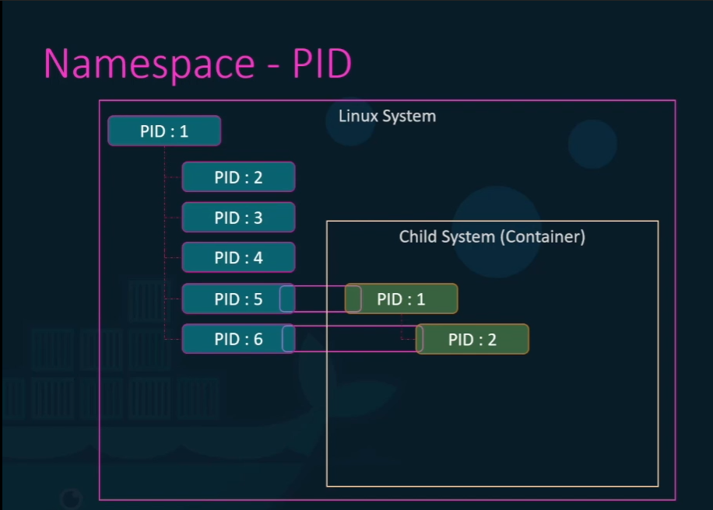

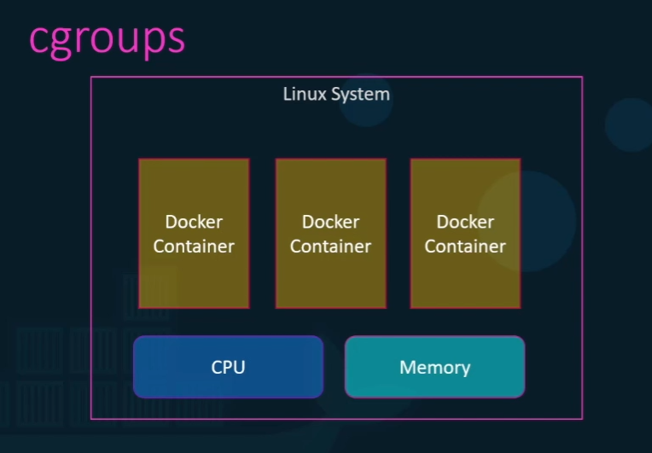

By default docker and containers uses same CPU and memory, to restrict the usage of CPU and memory we uses cgroups.

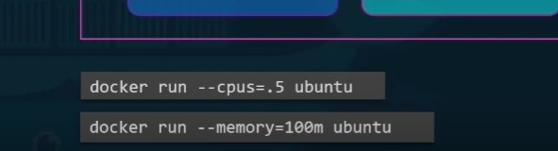

Using these commands we restrict theCPU and memory for containers



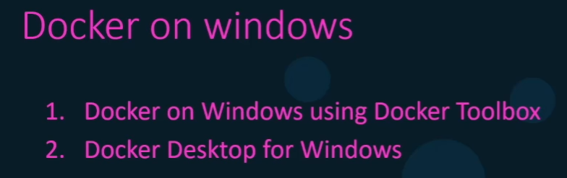

Docker Toolbox: Install oracle Virtual box of ubuntu and then install docker on it.

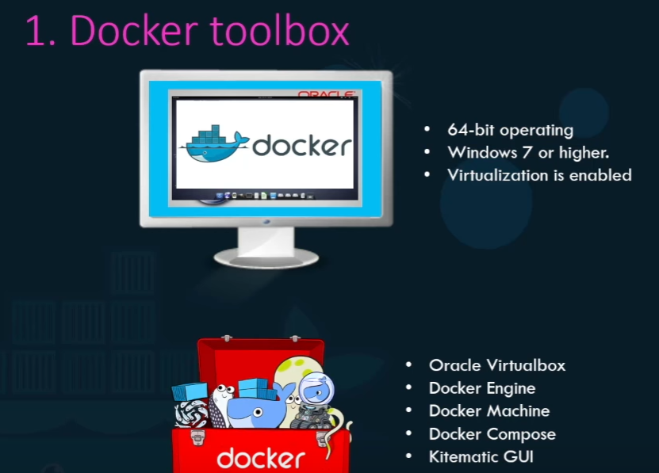

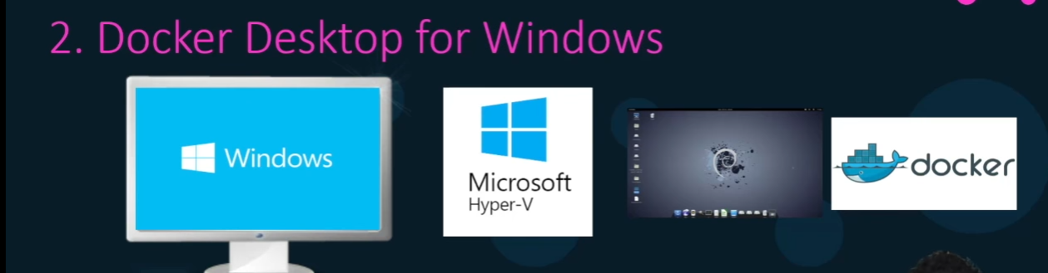

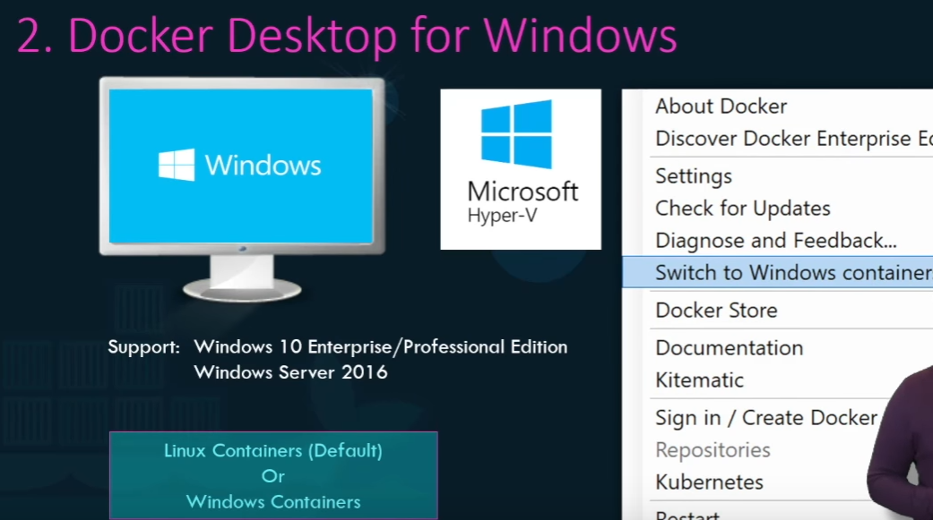

Early 2016 micro soft announced windows containers.

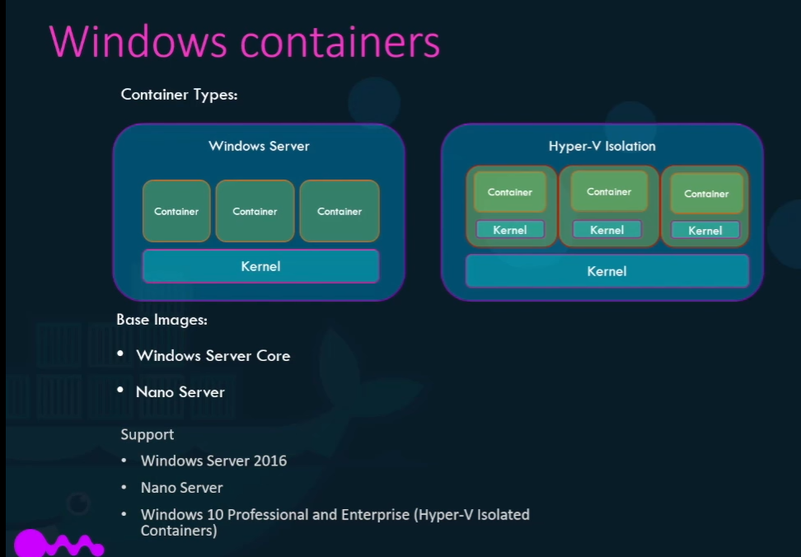

Similar to windows Mac as well



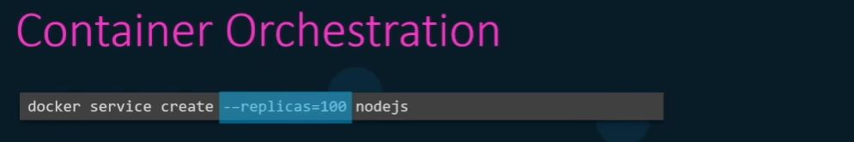

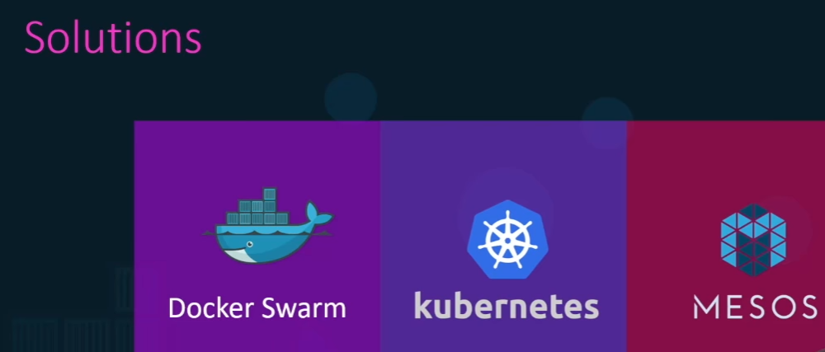



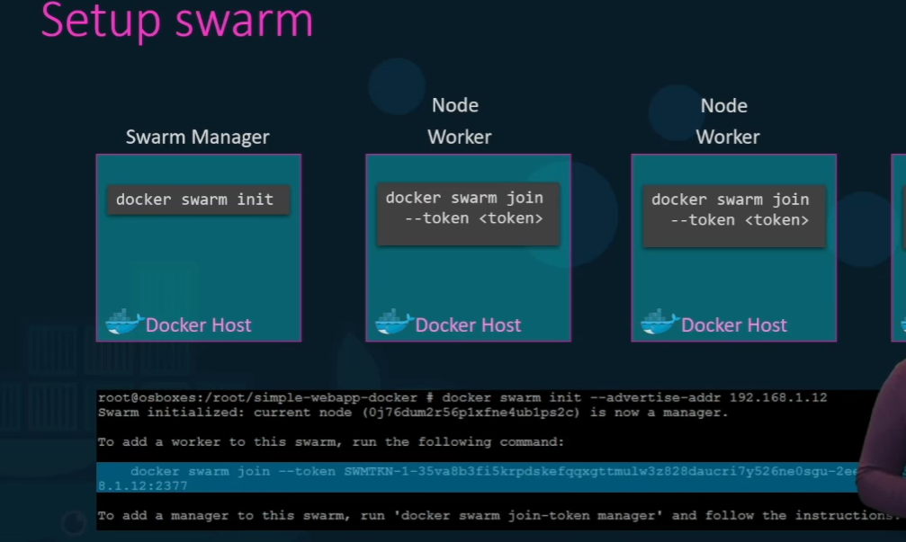

To manage load balancing

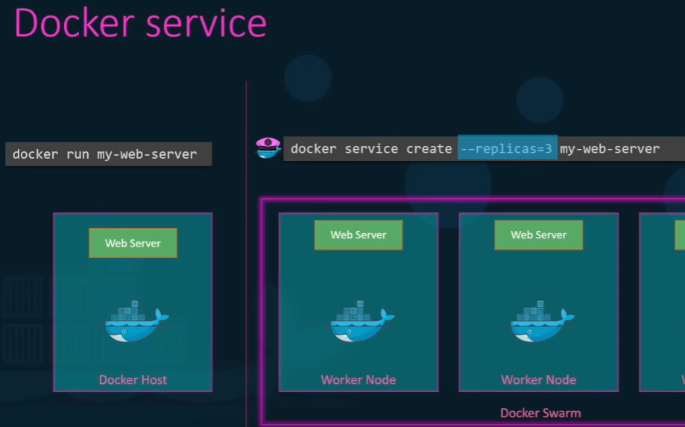

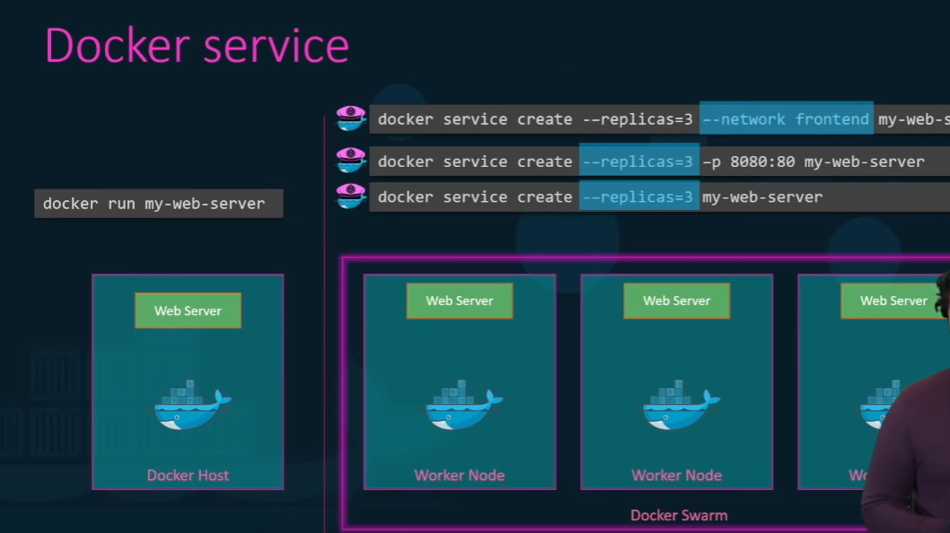



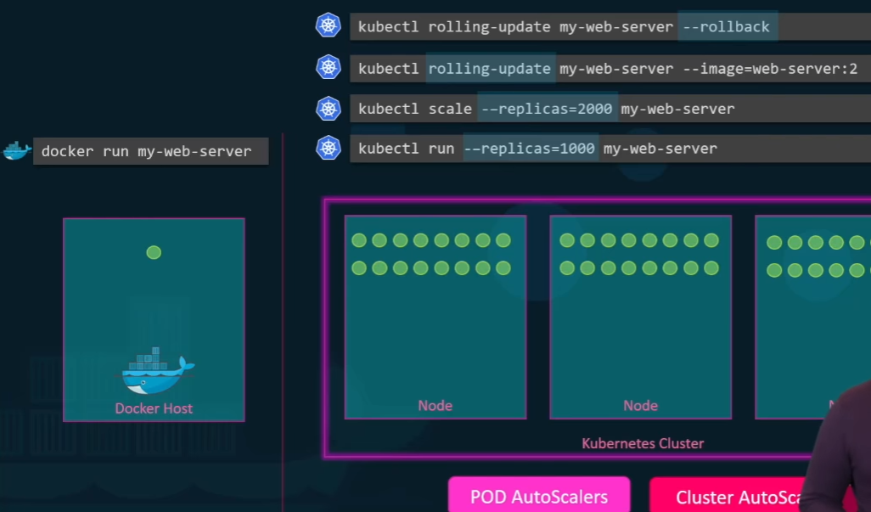

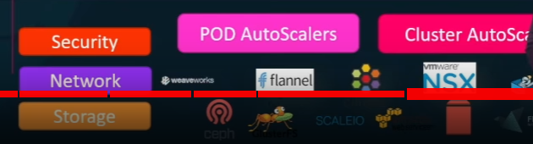

* Open architecture supports many vendors,
* Supports variety of applications
* Kubernates uses docker host to host the applications in the form of docker containers
* Kubernetes cluster consist of set of nodes.
* A node is a machine like physical or virtual software set of tools containers will be launched.

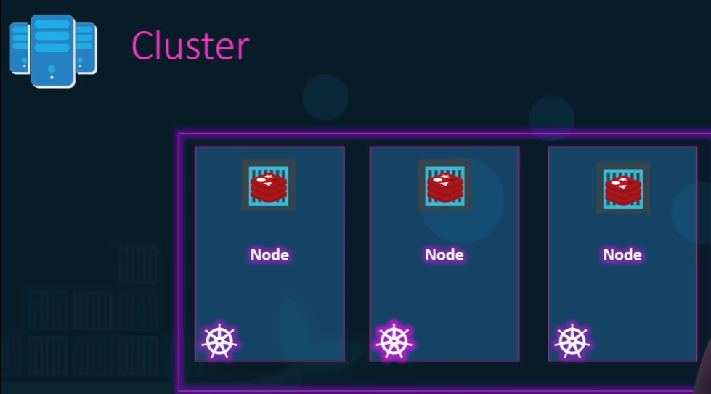

* Cluster is a set of nodes if 1 node fails it takes data from other nodes.
* Cluster is responsibled by master

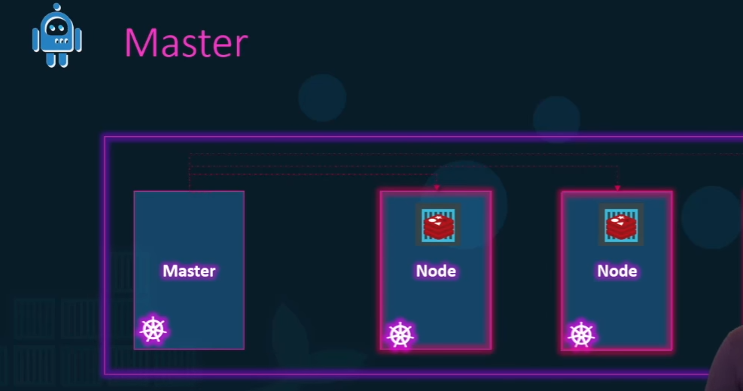

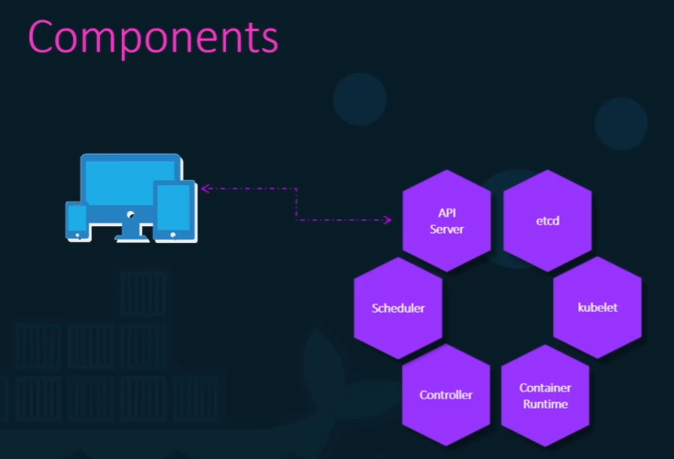

Users and Cli all talks with api server.

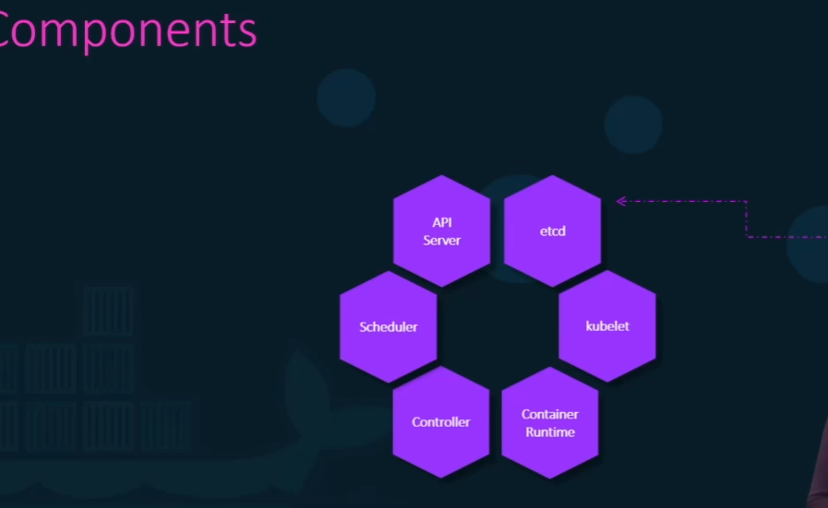

Etcd stores all key value pairs.

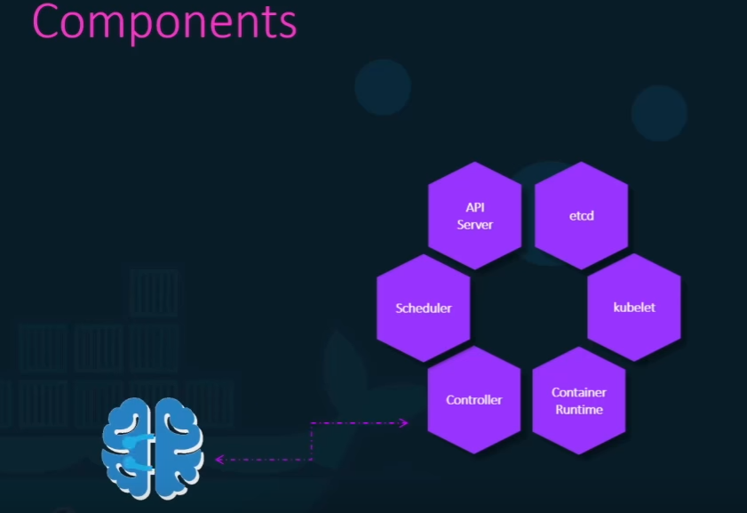

Controllers helps to bring the application up if anything goes down.

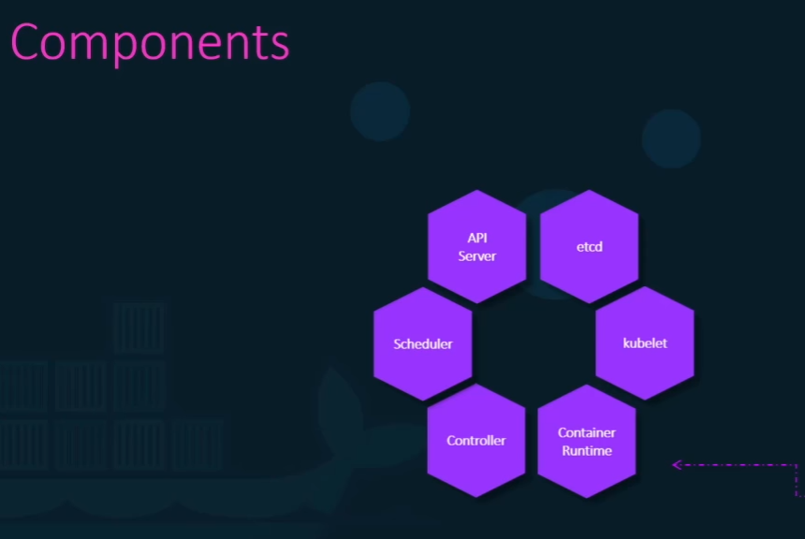

Conatiner runtime helps to run the application in this case it’s a docker.

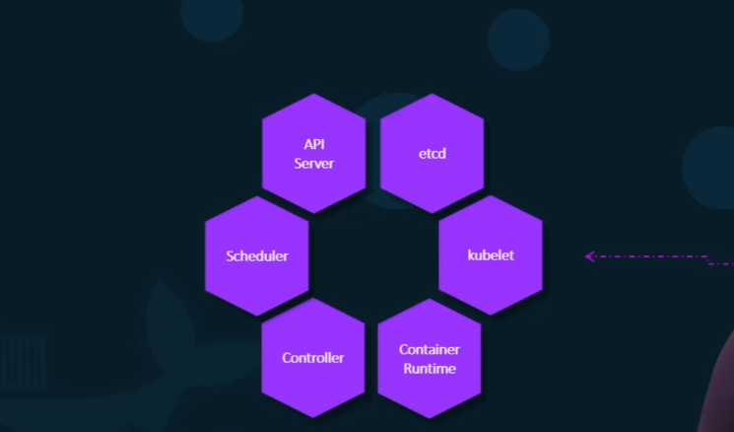

Kubelet is an agent that runs each node in cluster.

Kubectrl is an kubernatic cli which is used manage on kubernatic cluster to get cluster related information, status of the nodes in cluster

